K.E.T’s V.G. VAZE COLLEGE
Roll: A014 Name: Halpani Priyanshi Vinod
Pactical 1
Practical 1
1A | Installation of RHEL 6.X  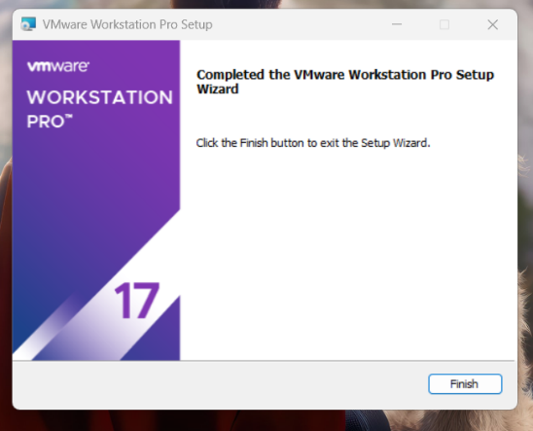  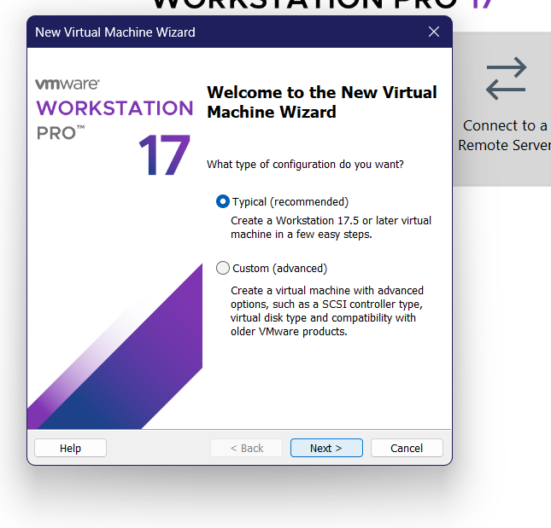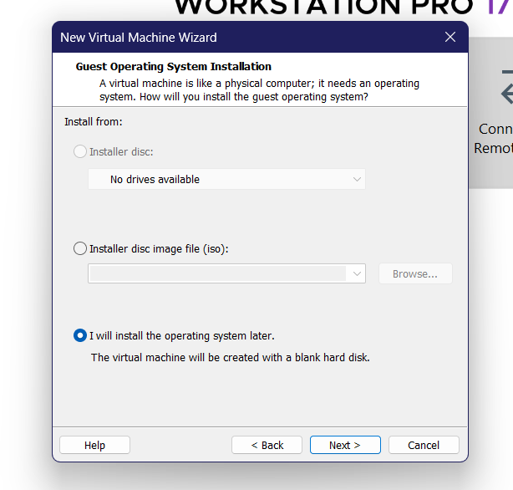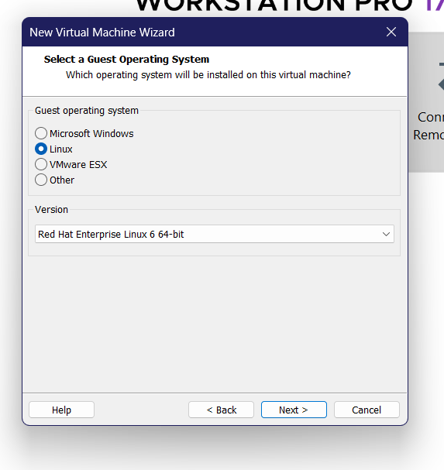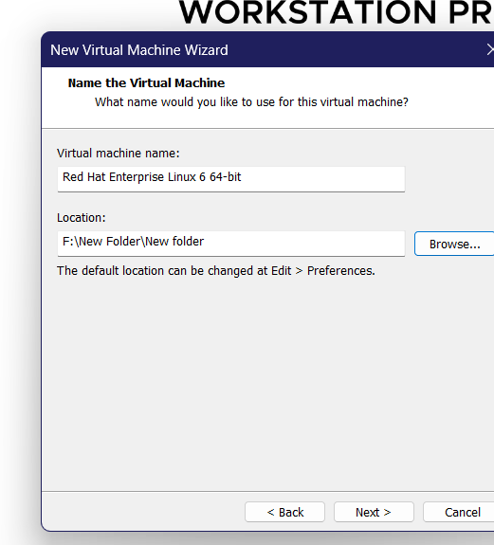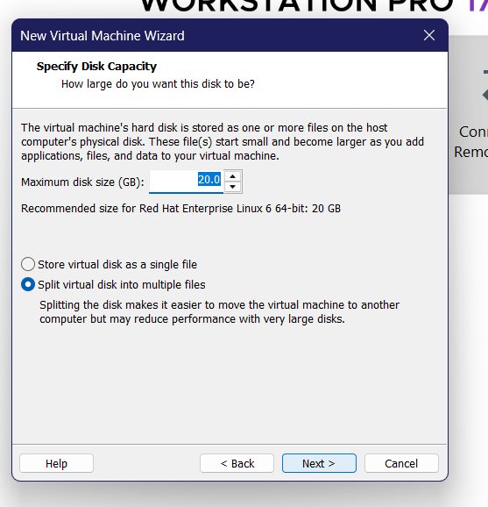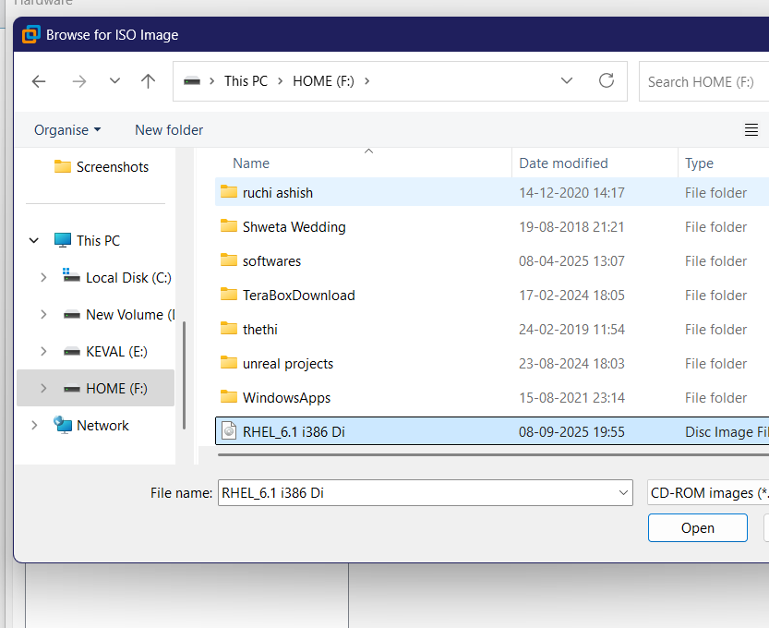  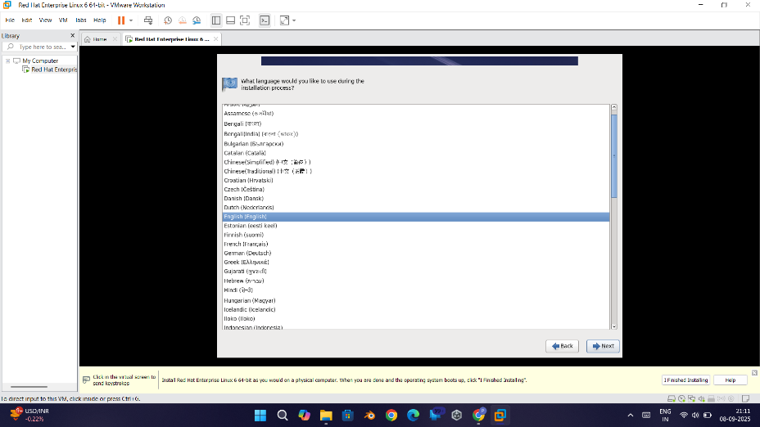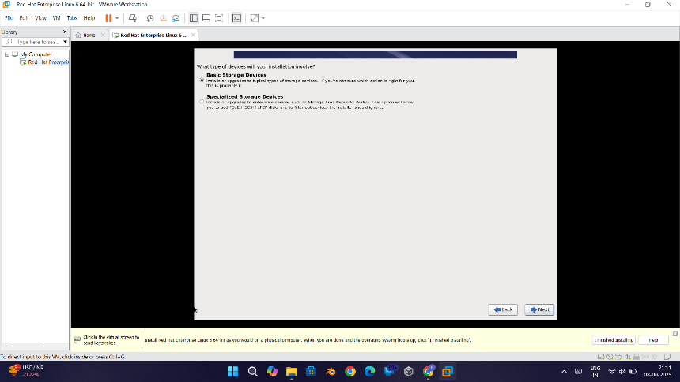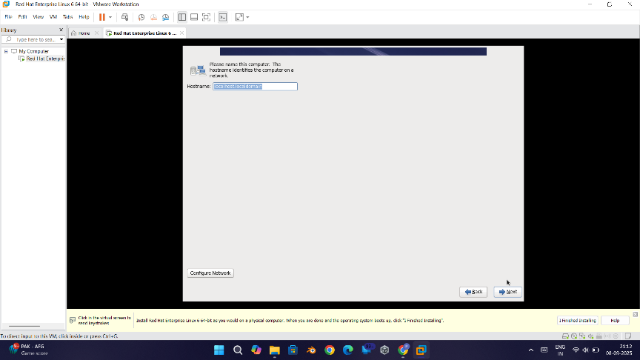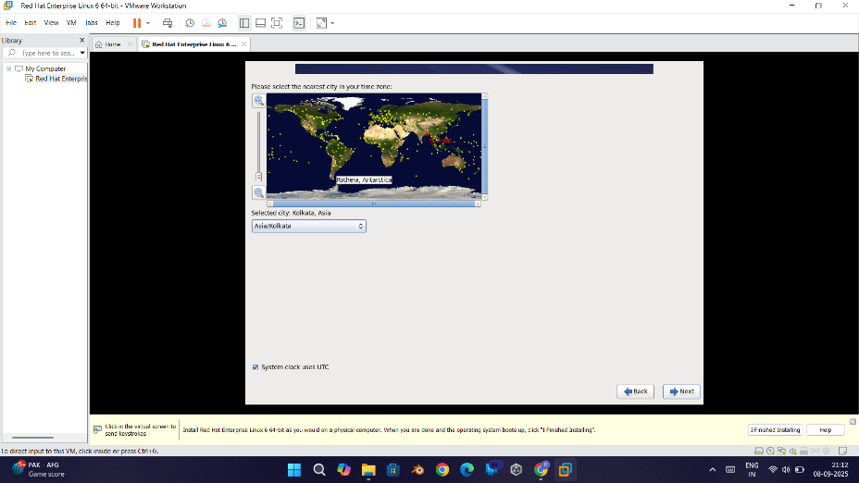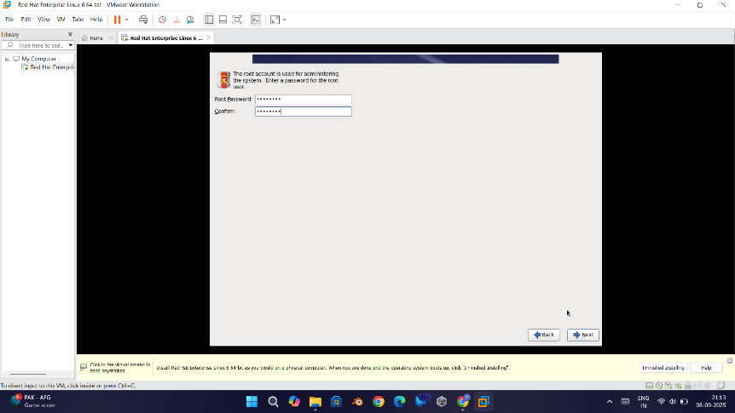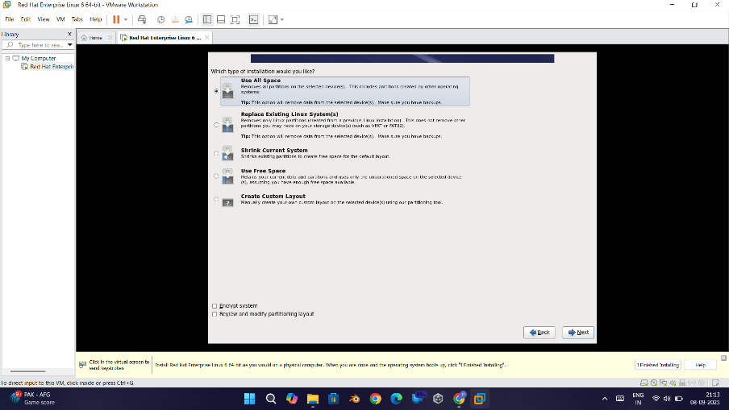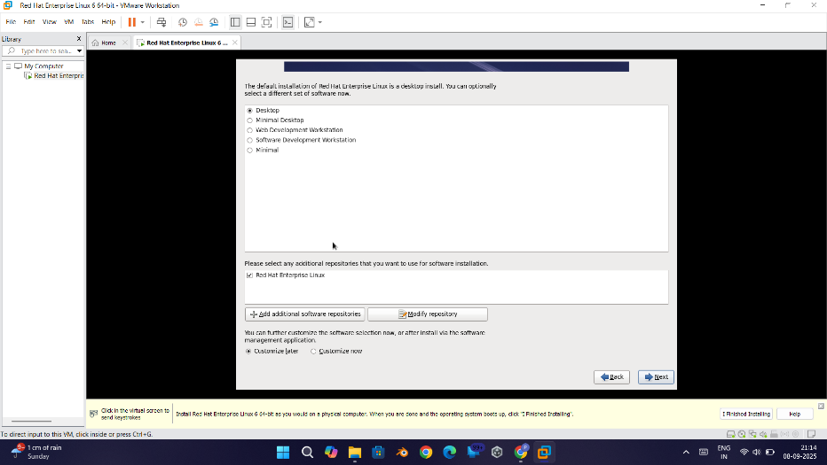  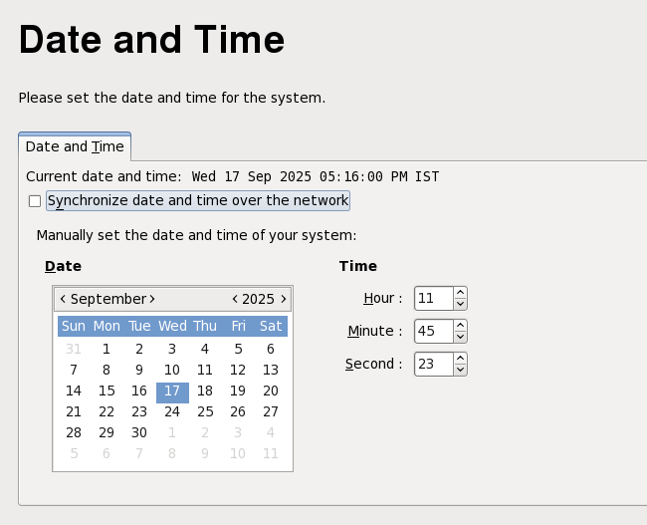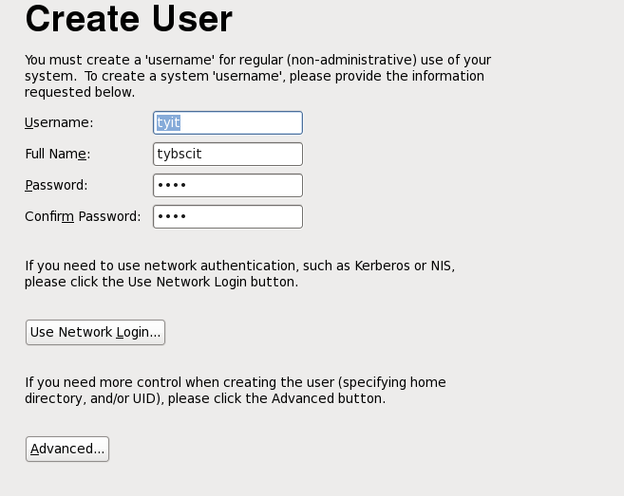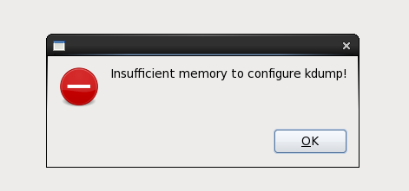

K.E.T’s V.G. VAZE COLLEGE
Roll: A014 Name: Halpani Priyanshi Vinod
Pactical 2
Practical 2 | Graphical User Interface and Command Line Interface and Processes.
2A | Exploring the Graphical Desktop  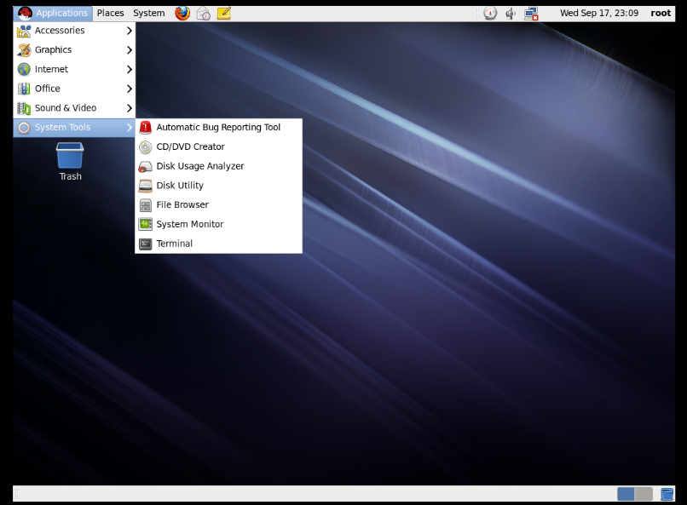  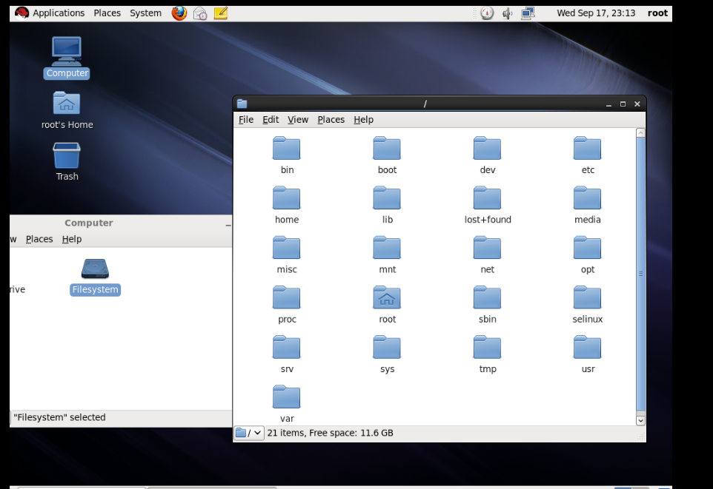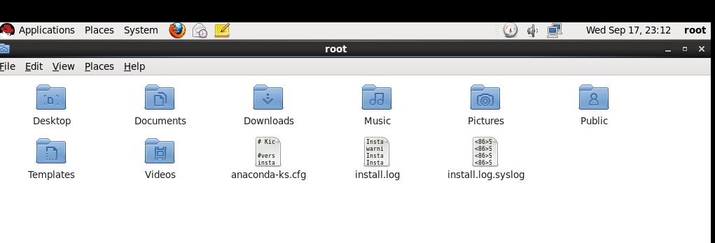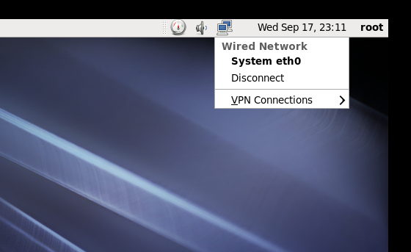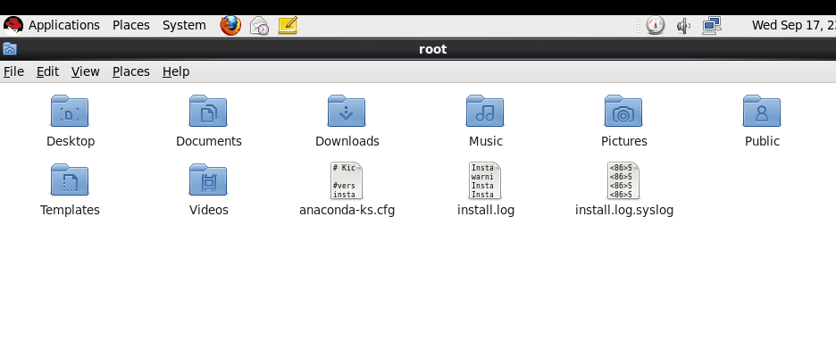
2B | The Command Line Interface  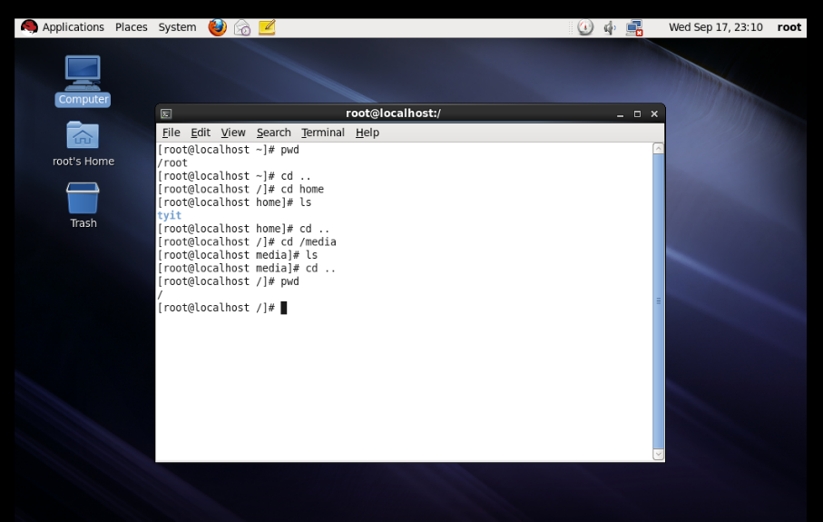  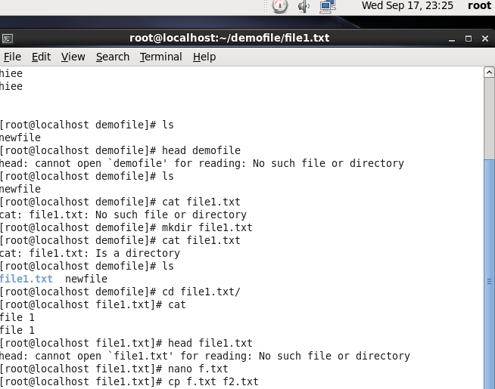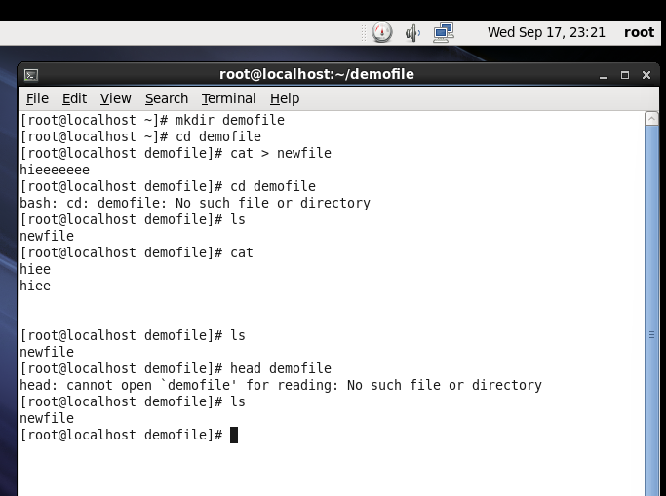
2C | Managing Processes  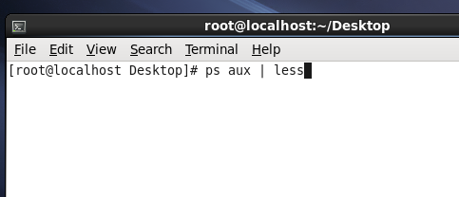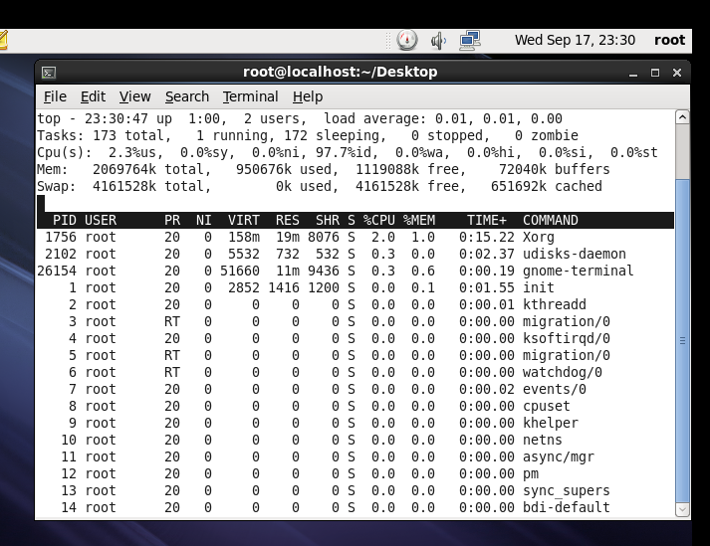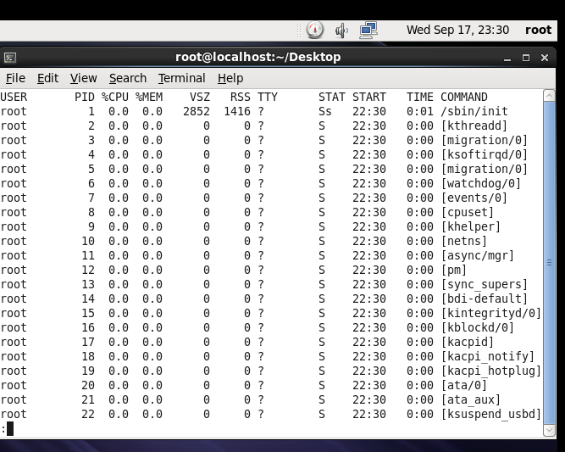

K.E.T’s V.G. VAZE COLLEGE
Roll: A014 Name: Halpani Priyanshi Vinod
Pactical 3
Practical 3 | Working with Users, Groups, and Permissions
3A | Users & Groups :  1)create a user information with a home directory and a user id 1286  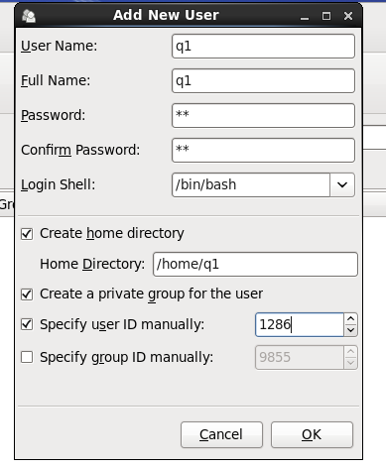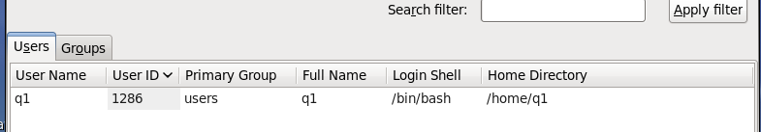  2) create a user tech with a user id 9846 and group id 1689  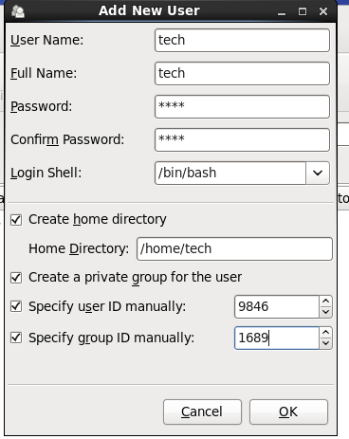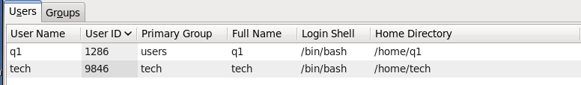  3) remove tyit1 user from project group  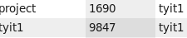  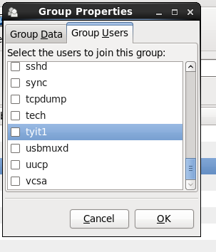  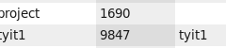  4)add username tyit using user add command  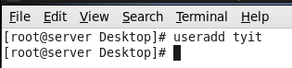  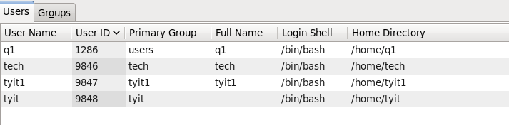  Create a password using passwd command  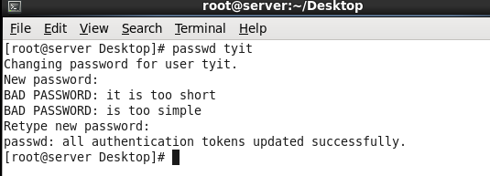  Login using this user  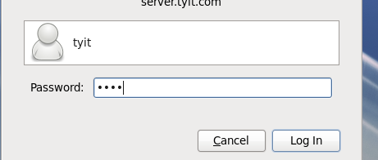    5) examine home directory of each user  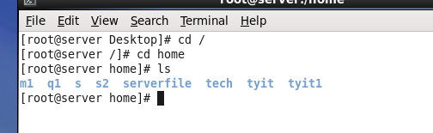  6)examine /etc/shadow  /etc/group  /etc/passwd  With respect to new addition  7)Create 2 groups manager and staff add user to the group  8)login using root account with del command.  9)delete any tow users using various options of userdel command  Permissions:  created a main directory  create 7 subdirectories and 2 files in the main directory  change permissions.  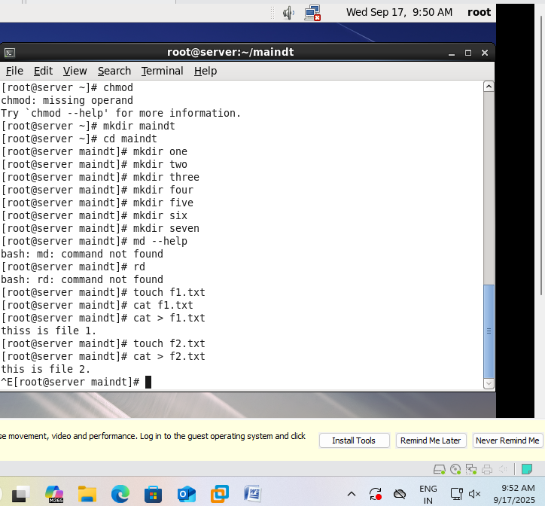  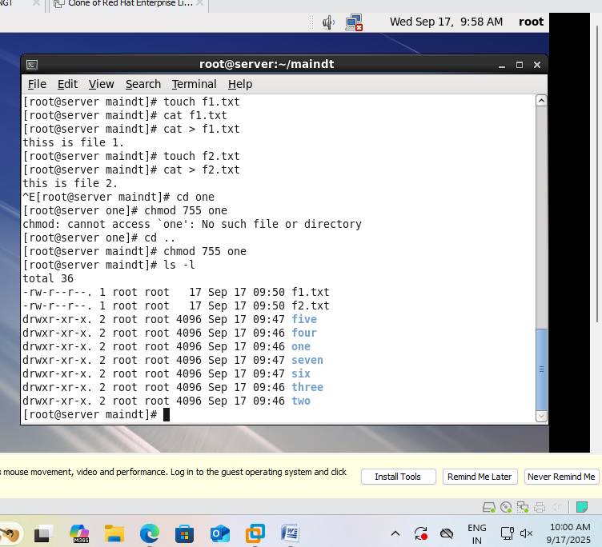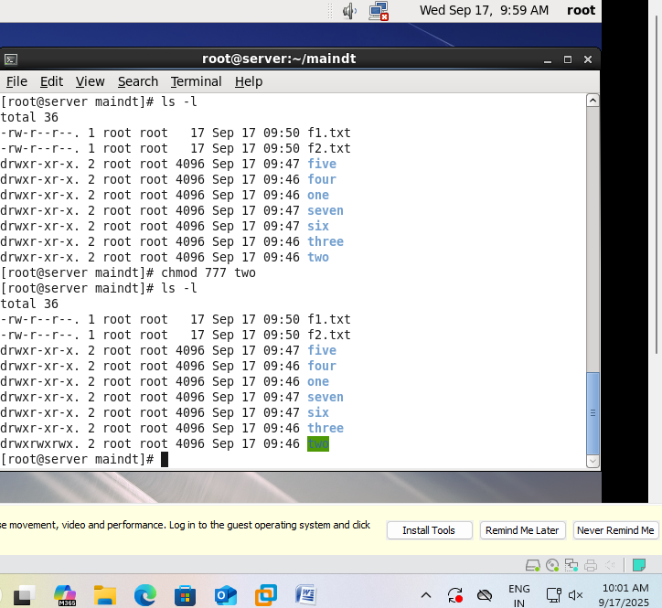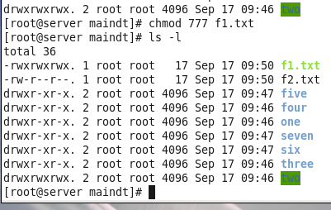

K.E.T’s V.G. VAZE COLLEGE
Roll: A014 Name: Halpani Priyanshi Vinod
Pactical 4
Practical 4 | Working with RPM Storage and Networking
4A | Using Query Options  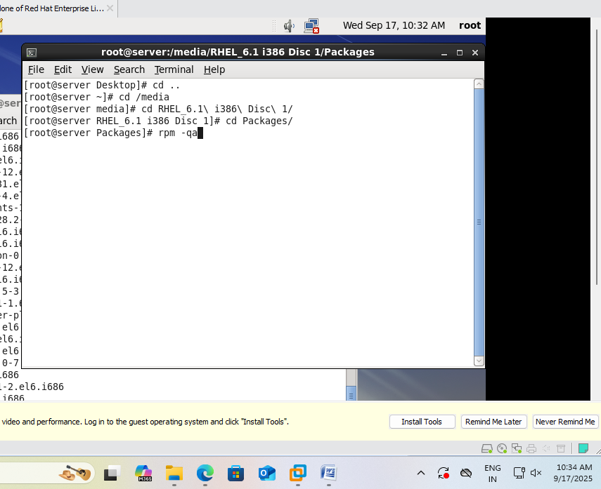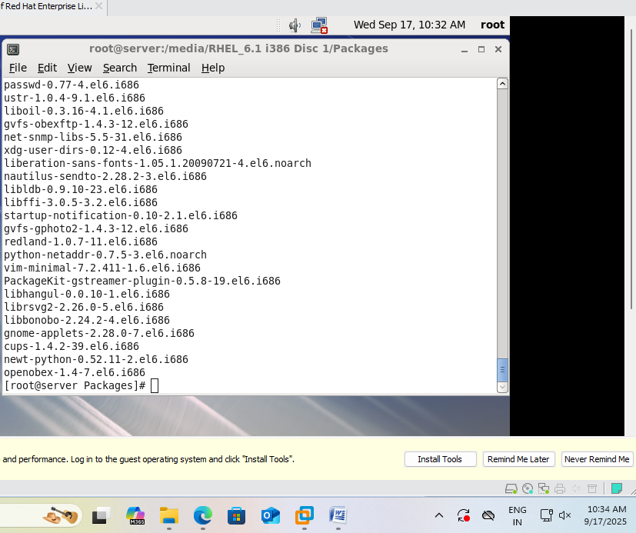
4B | Extracting Files From RPMs  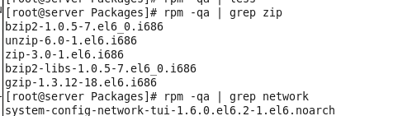  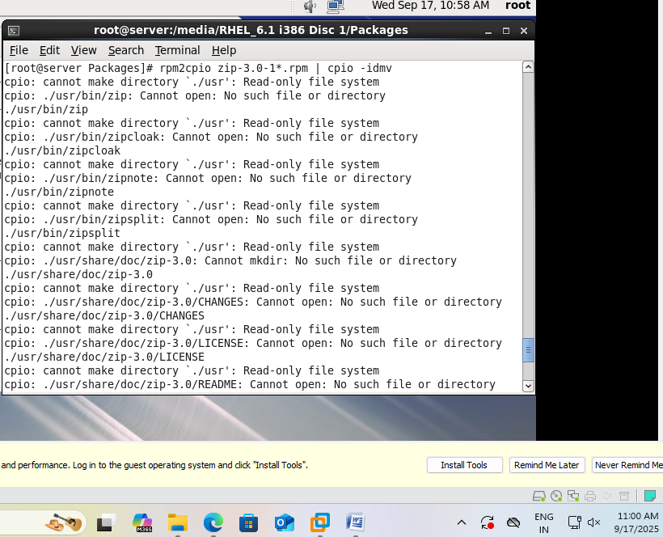
4C | Configuring and Managing Storage  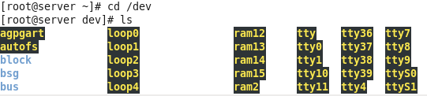  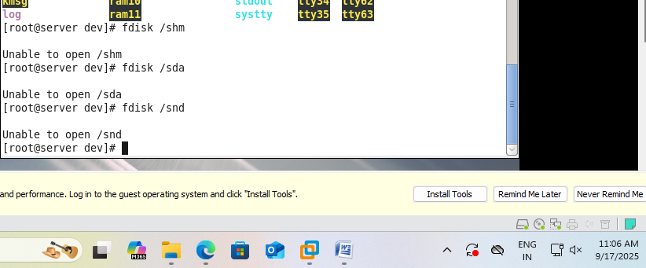
4D | Connecting to the Network  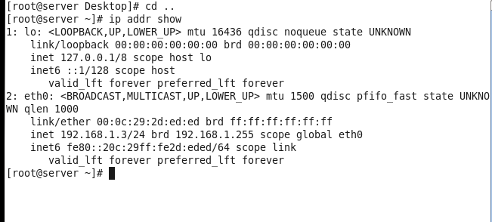  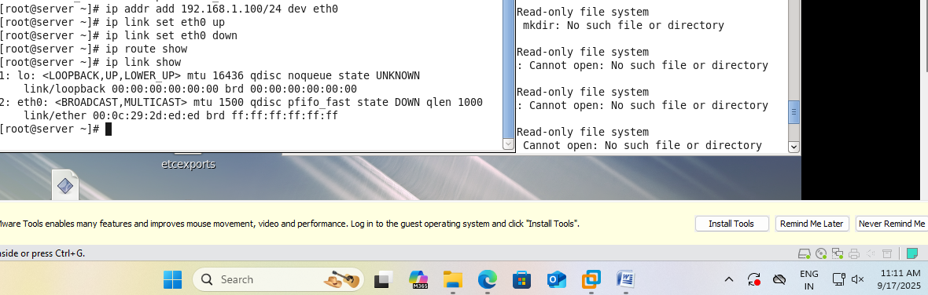

K.E.T’s V.G. VAZE COLLEGE
Roll: A014 Name: Halpani Priyanshi Vinod
Pactical 5
Practical 5 | Configuring Server for File Sharing
5A | Configuring NFS Server and Client  On the server machine (RHEL1)  Step 1: Install nfs package  #rpm -qa | grep nfs [to search installed nfs packages]  #ls nfs* [to show all the nfs packages available]  #rpm -ivh [packageName] [to install a package]  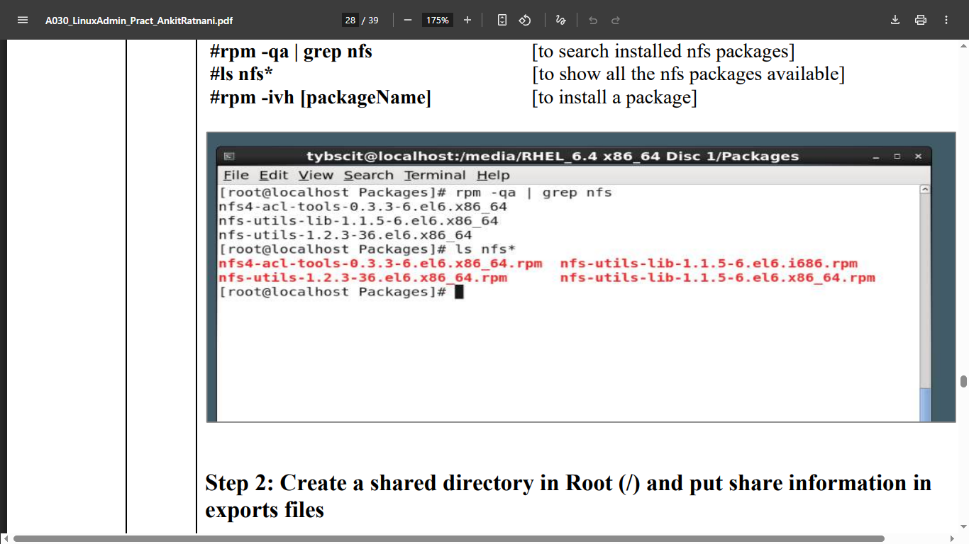  Step 2: Create a shared directory in Root (/) and put share information in exports files  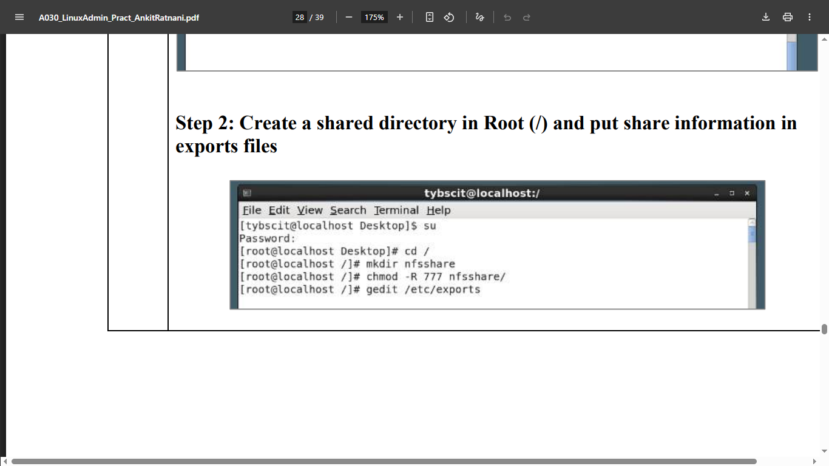  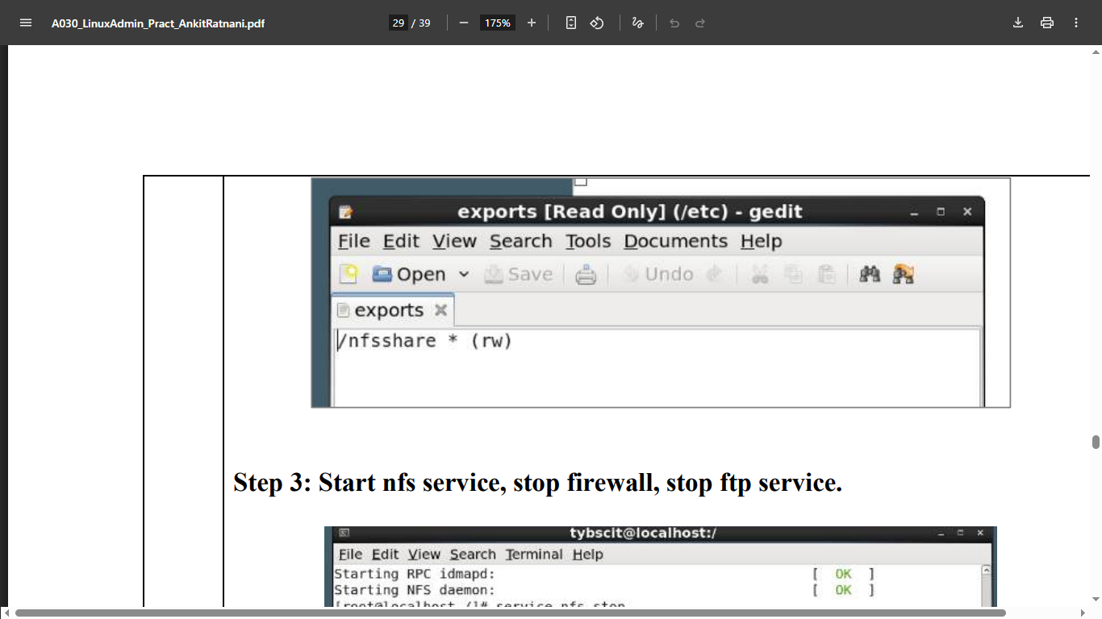  Step 3: Start nfs service, stop firewall, stop ftp service.  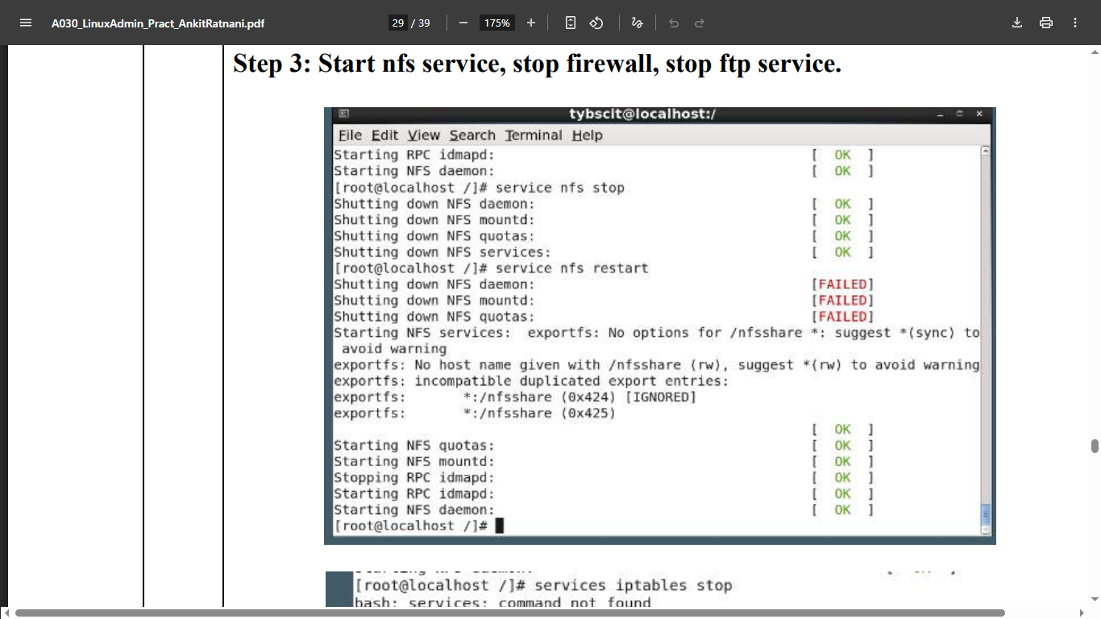  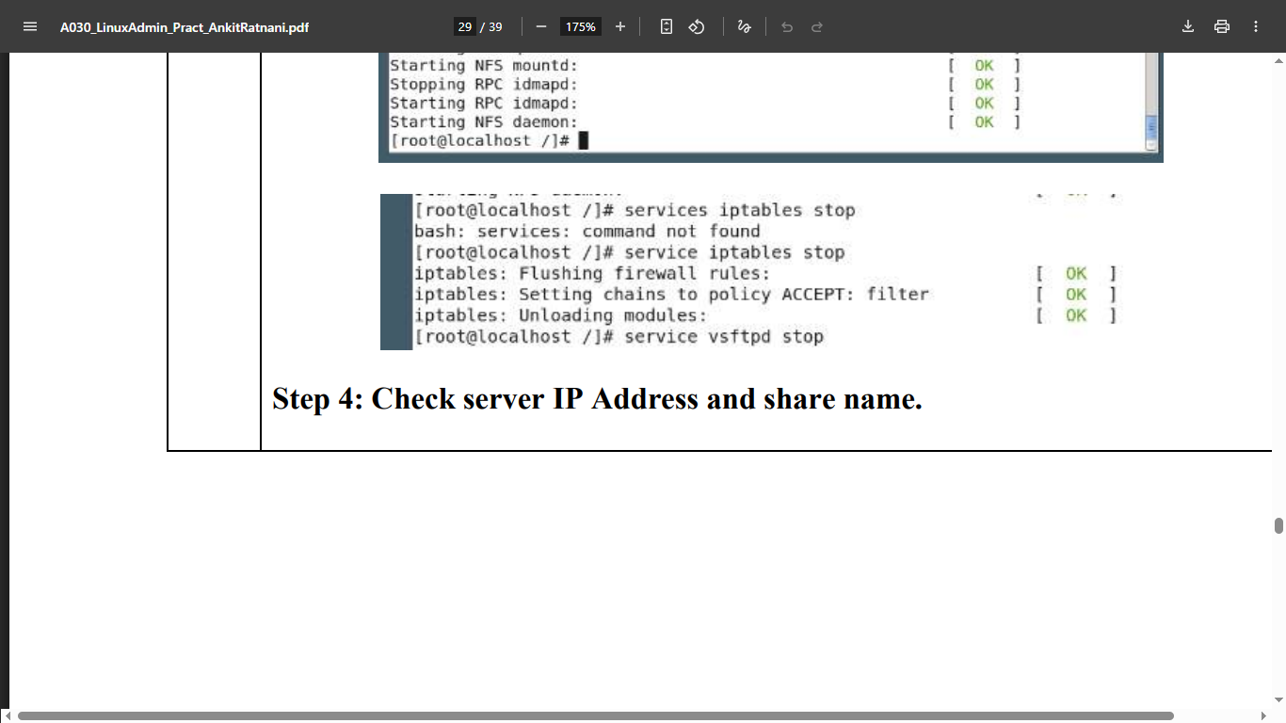  Step 4: Check server IP Address and share name.  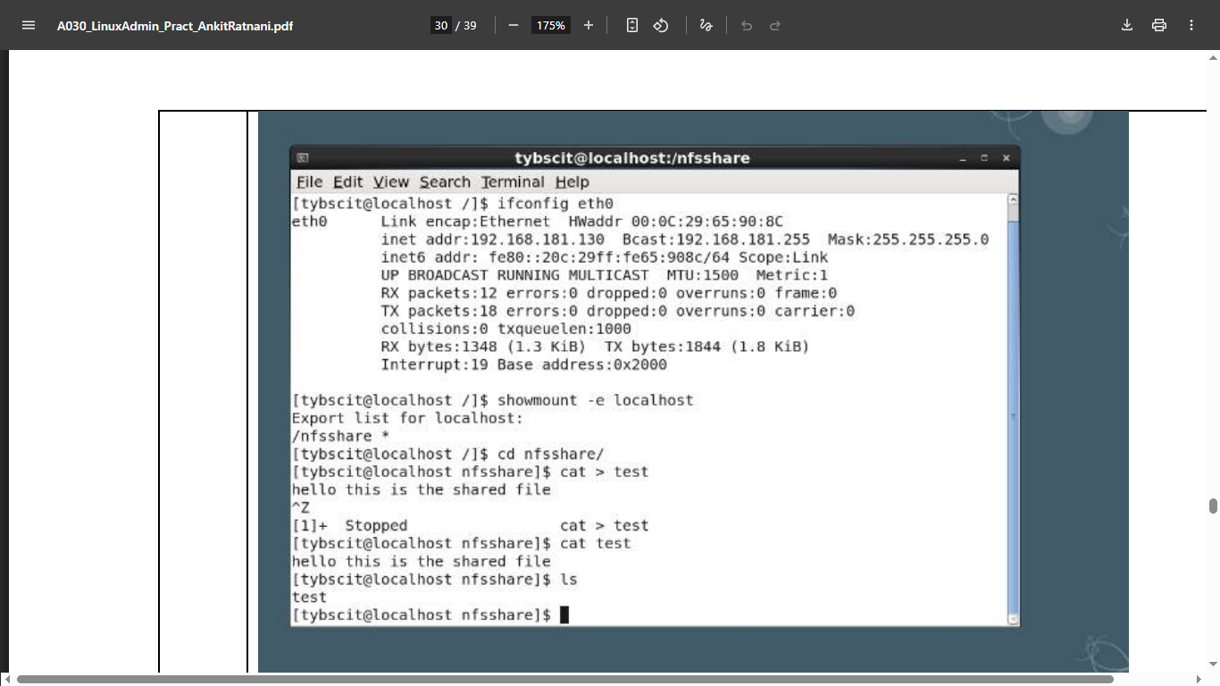  On the client machine (RHEL2)  Step 1: Create a mount point /clientnfs #mkdir /clientnfs  Step 2: mount the server location to mount point.  #mount –t nfs 192.168.181.130:/nfsshare /clientnfs  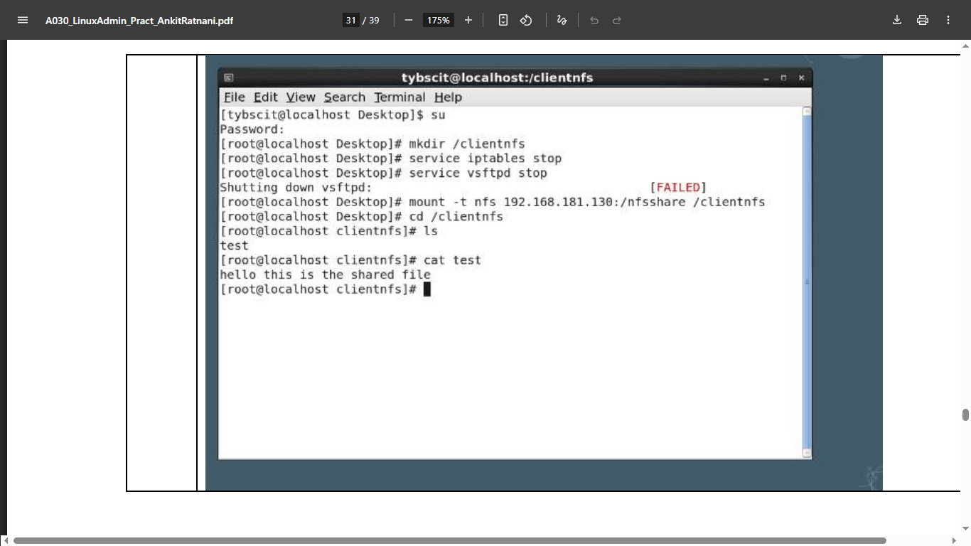
5B | Configuring Samba
5C | Configuring FTP

K.E.T’s V.G. VAZE COLLEGE
Roll: A014 Name: Halpani Priyanshi Vinod
Pactical 6
Practical 6 | DNS, DHCP and Mail Server
6A | Configuring DNS  Go to main -> terminal  Gedit /etc/hosts  Add after 2 line – 192.168.1.3 srver.tyit.com  Save  Gedit /etc/sysconfig/network-scripts/ifcfg.eth0  File open  Gedit /etc/sysconfig/networl  Localhost domain –delete  Write- server.tyit.com  Save  Gedit /etc/resolv.conf  Add NAMESERVER 192.168.1.3  Save  Cd /etc  Service network restart ok ok  If not then click on network manager to turn it on then try  Now, cd ..  Cd media/RHEL…./Packages  Now,  Rpm –ivh bind*  Install  Gedit /etc/named.conf empty  Install now properly  Ls bind*  Now,  Rpm –vh bind-9.7.3-2.e16.i686.rpm  Gedit /etc/named.conf  File will open  Options……?  Cd etc  Ls named*  Gedit /etc/named.rfc192.zones  Copy one zone “ “ in {….}  Than change name as zone ……?  And file reversed.zone  Cd .. (go to root)  Cd /var/named  Ls  Cp named.localhost Forward.zone  Cp named.loopback reversed.zone  Gedit forwar.zone  IN SOA server.tyit.com root.server.tyit.com { …}  IN NS server.tyit.com  SERVER IN A 1912.168.1.3  Gedit reversed.zone  IN SOA server.tyit.com root.server.tyit.com  IN NS sever.tyit.com  IN PTR server.tyit.com  Chgrp named forward.zoe  Ls –l  Chgrp named reversed.zone  Ls –l  Service named start  Dig server.tyit.com  If timed out the turn on the network manager(systemeth0)  The try it again  Requirmentd gor configuration DNS  Bind package create forward & reversed file  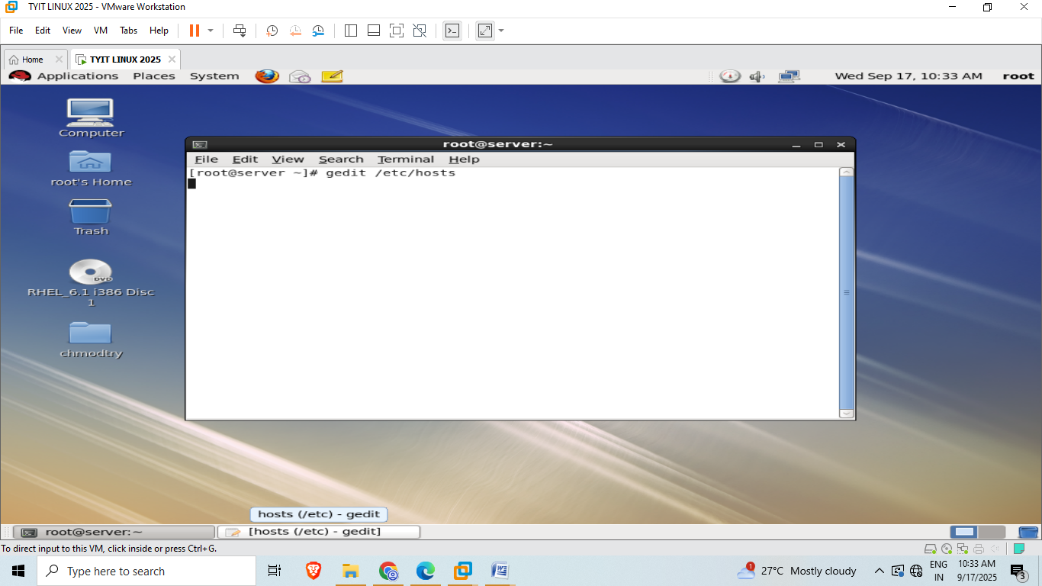    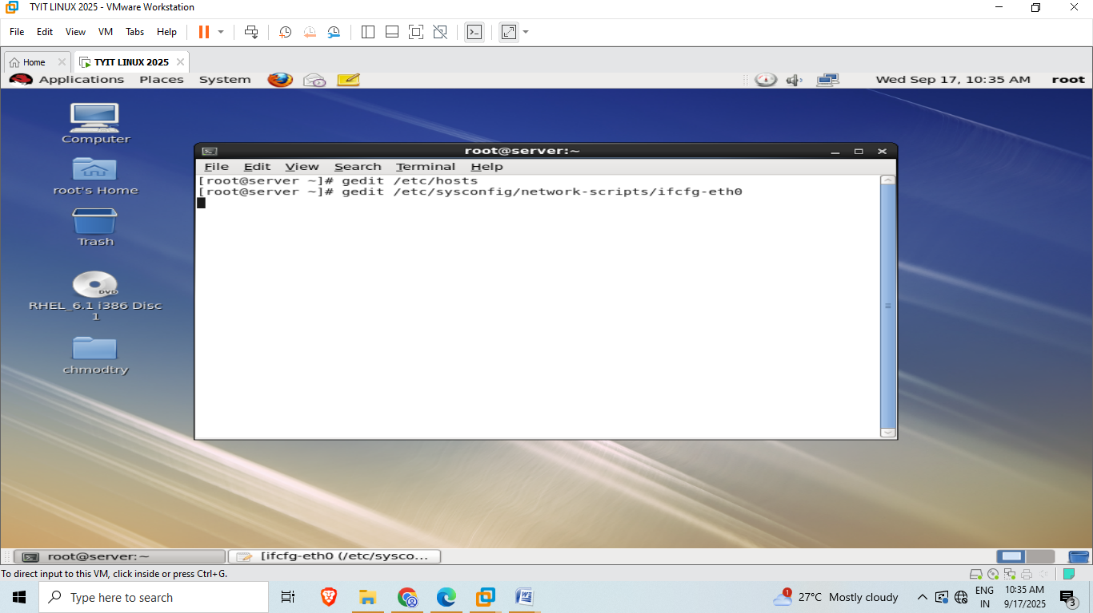  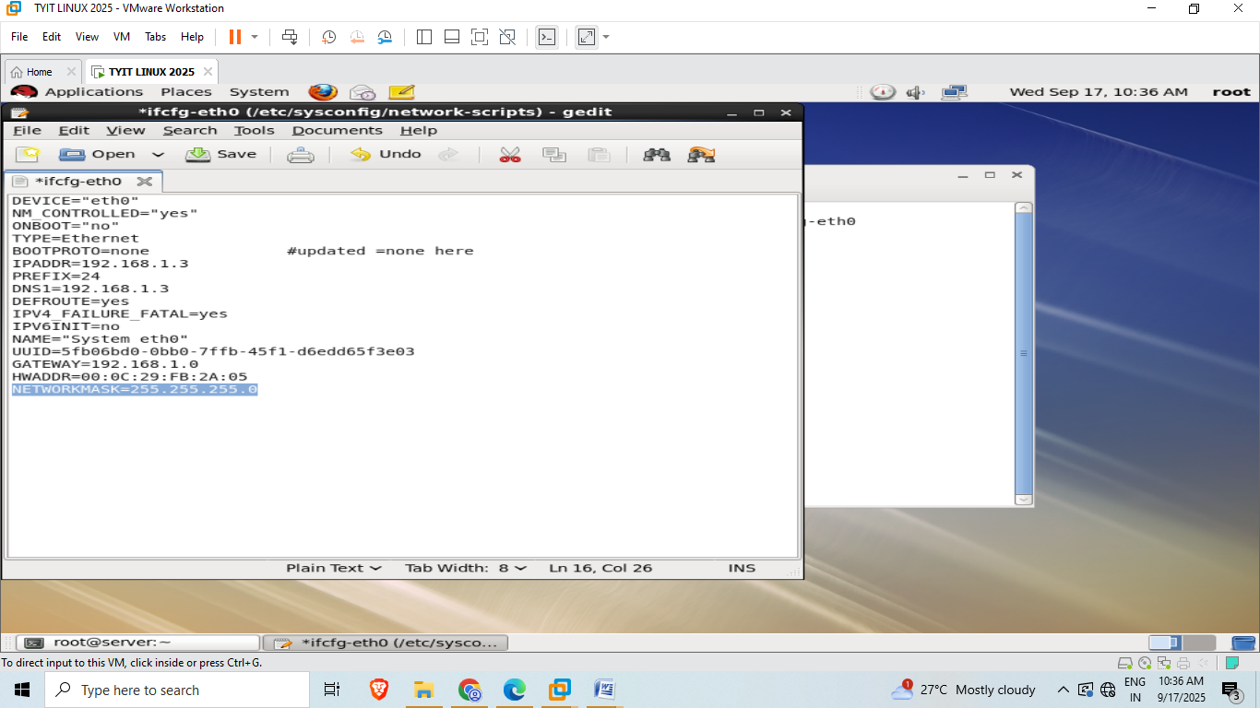  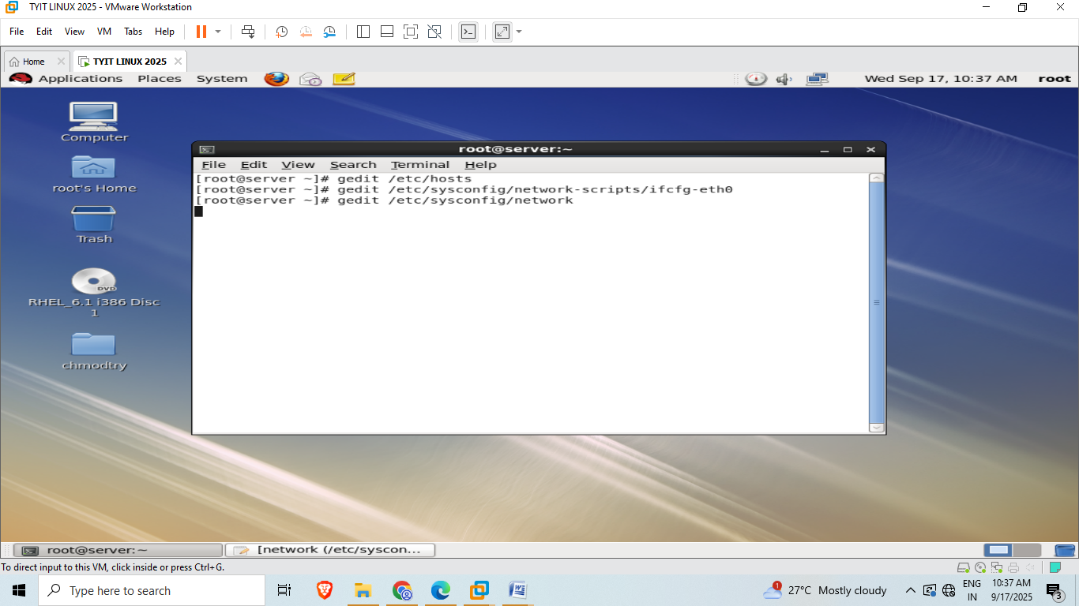  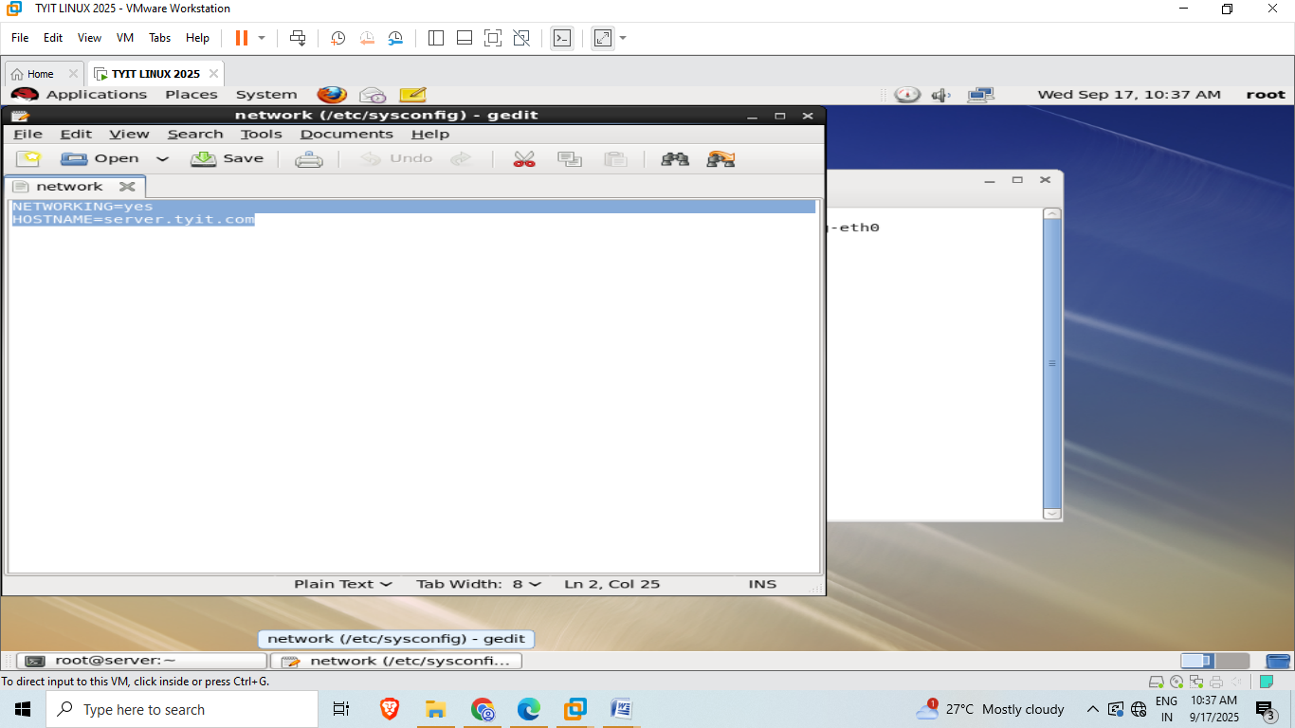  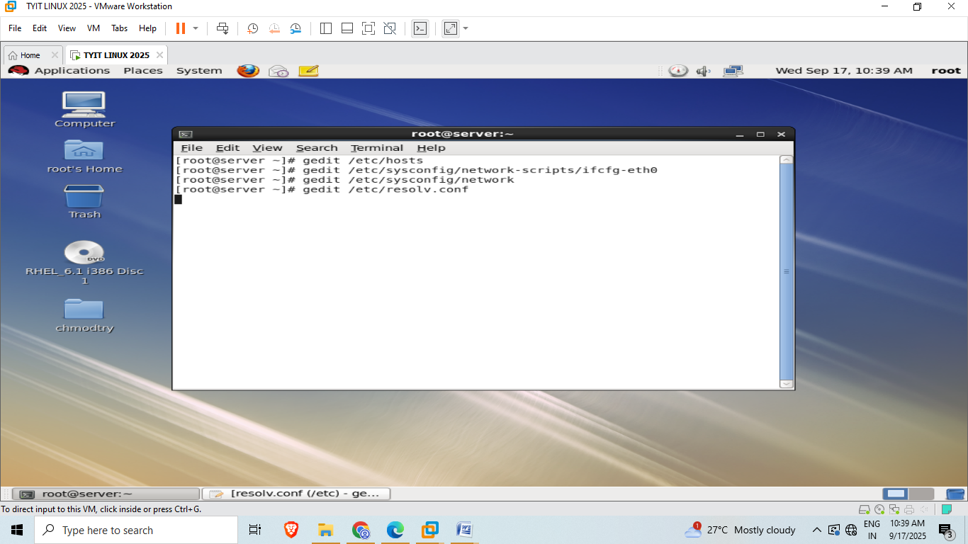  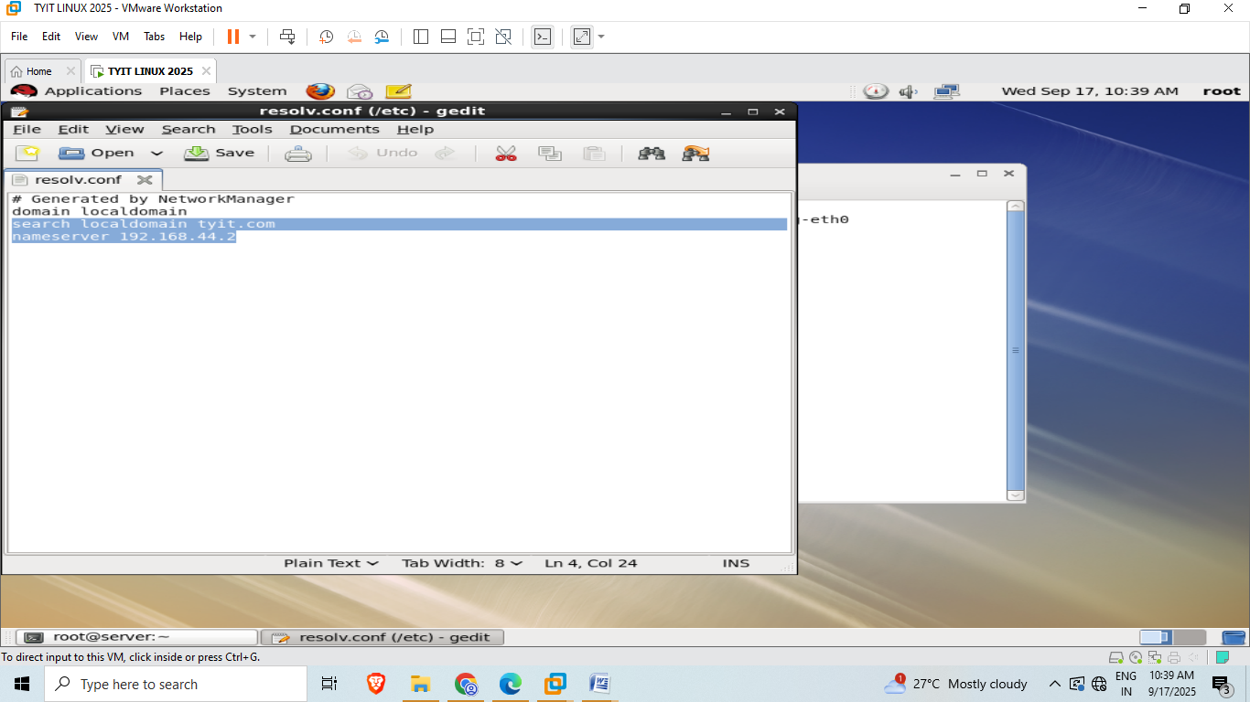  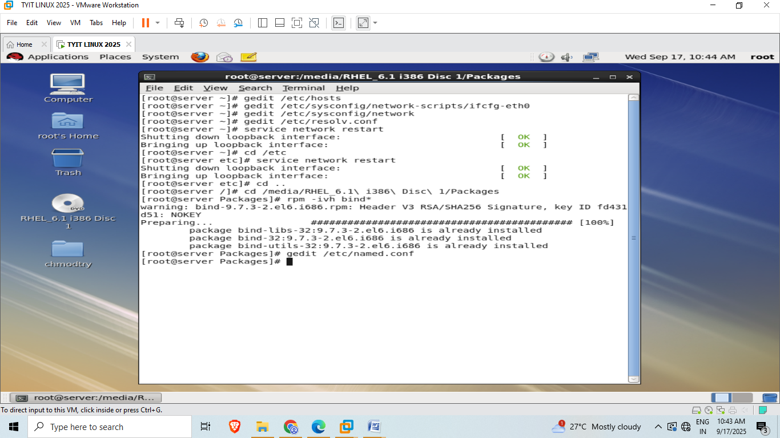  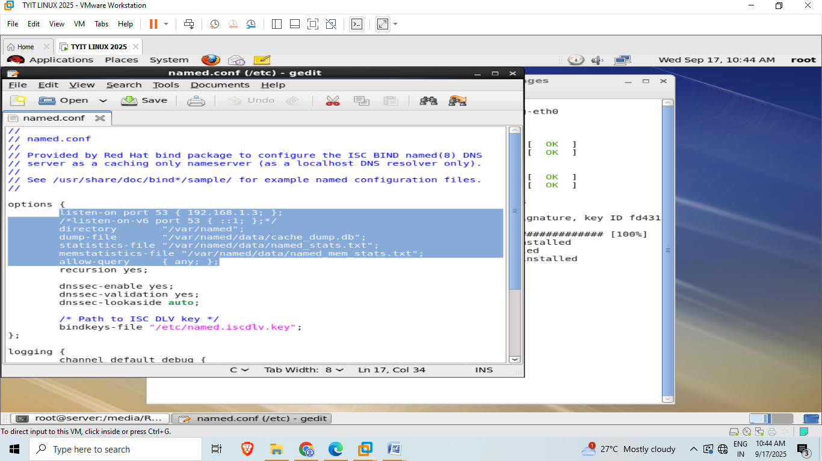  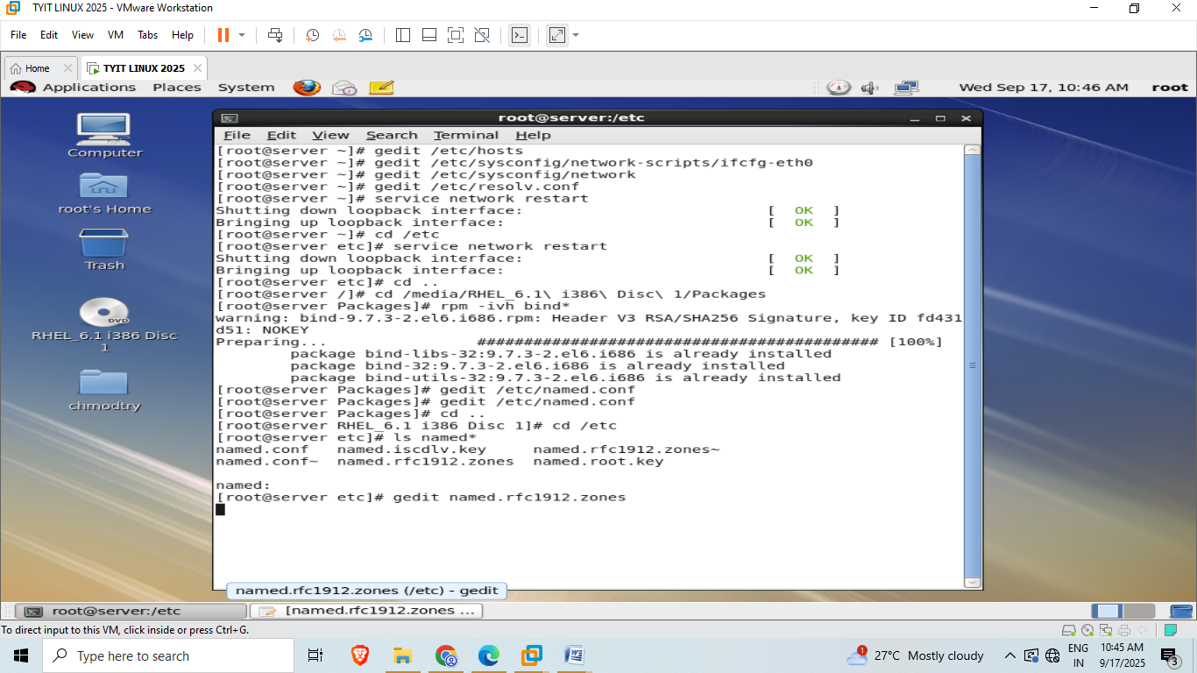  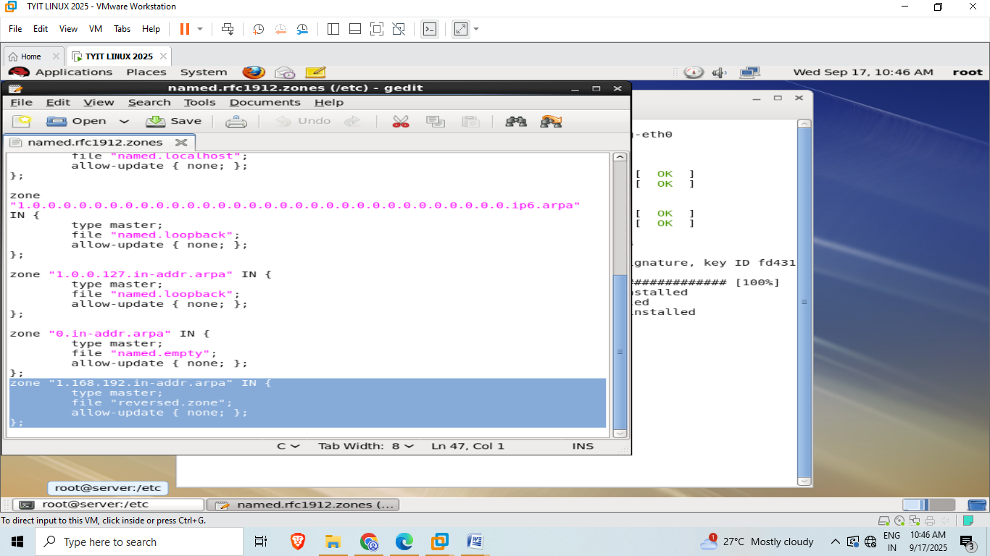  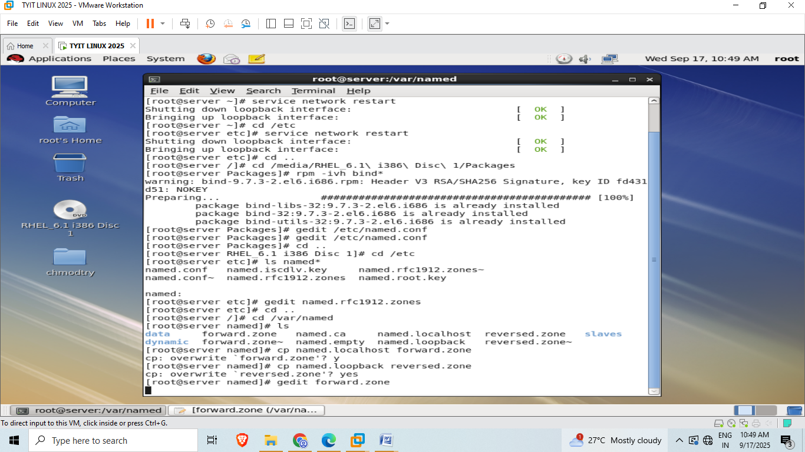  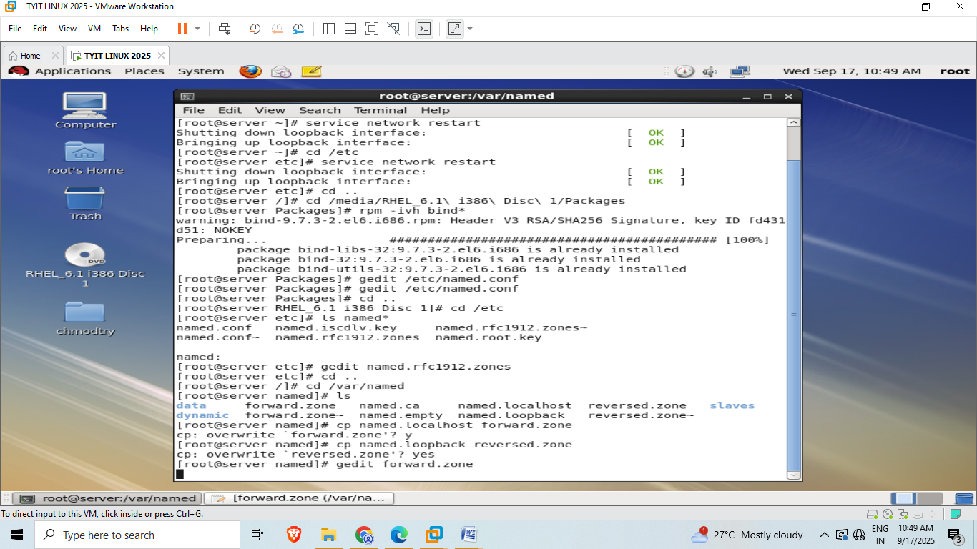  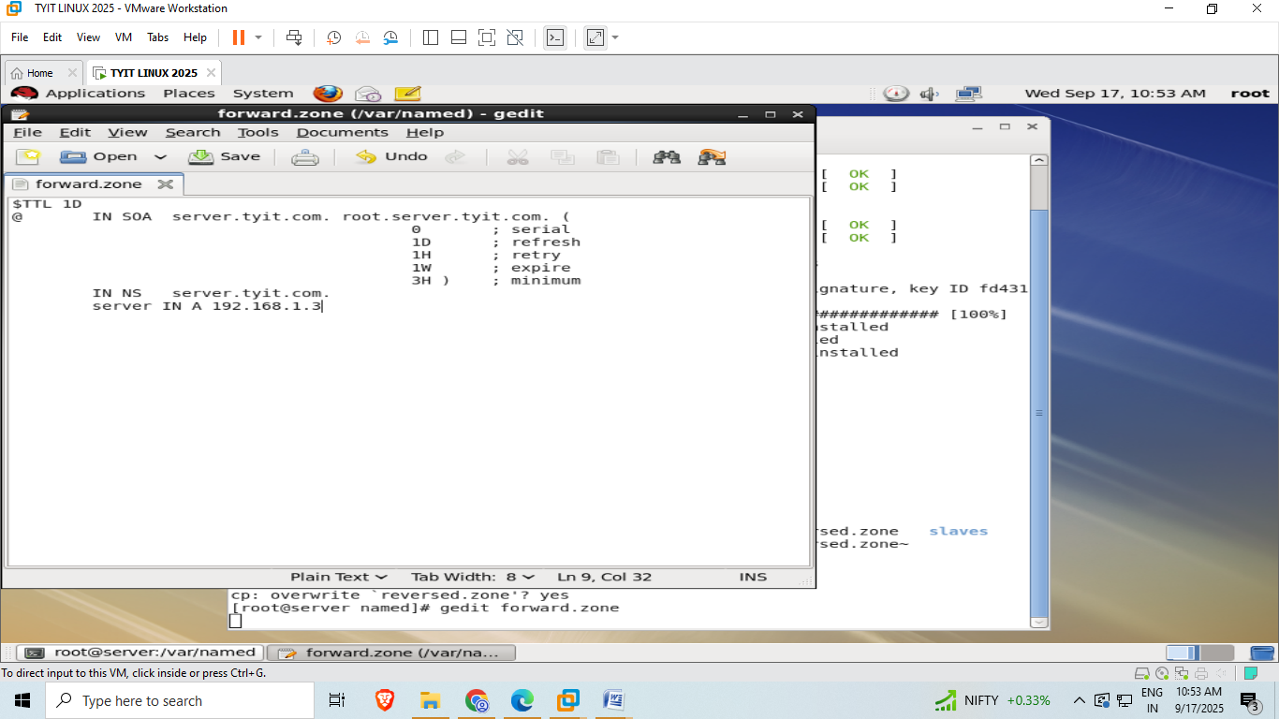  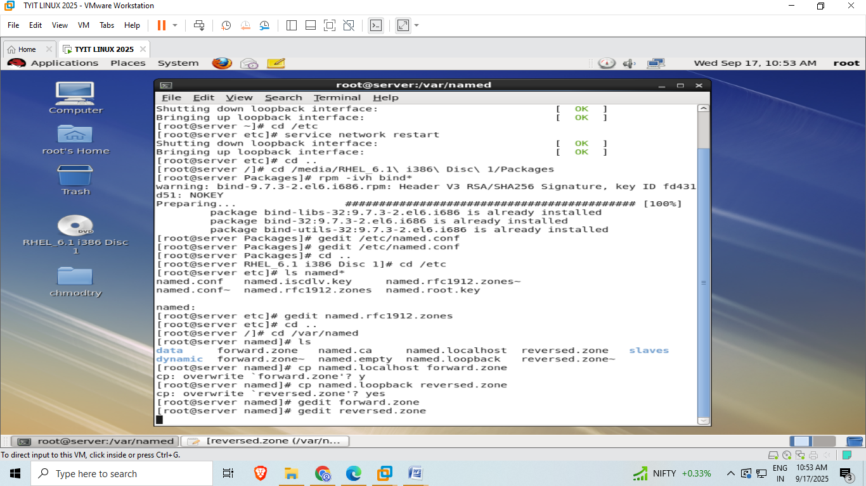  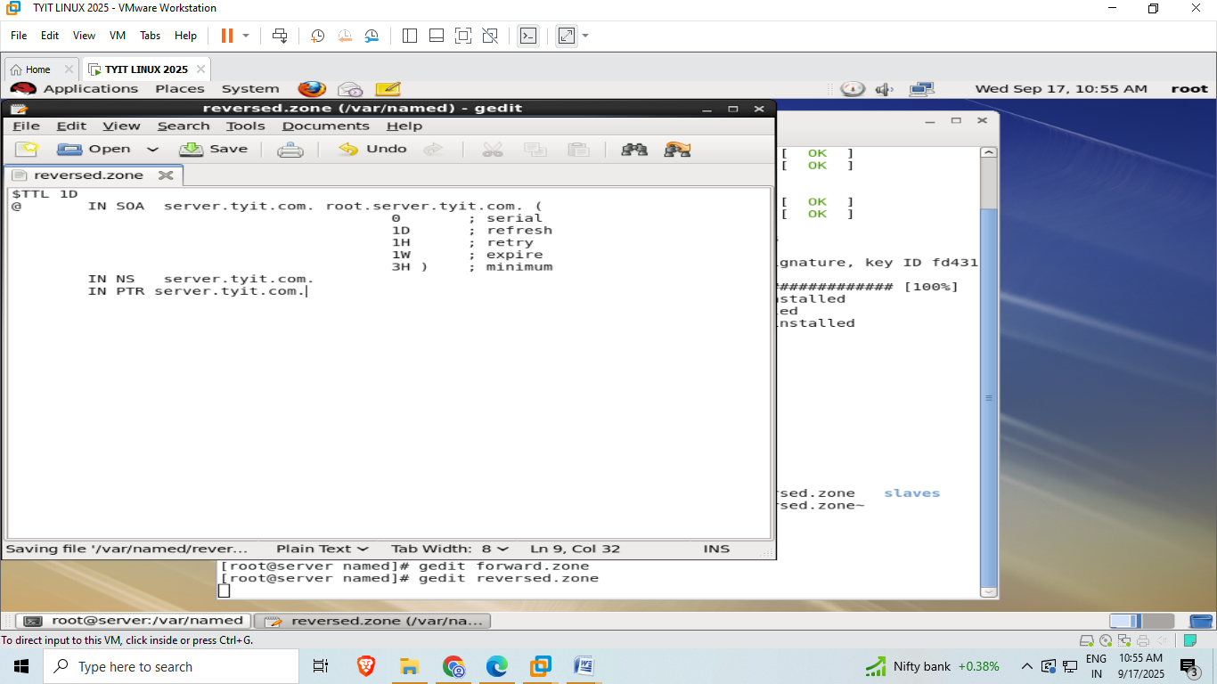  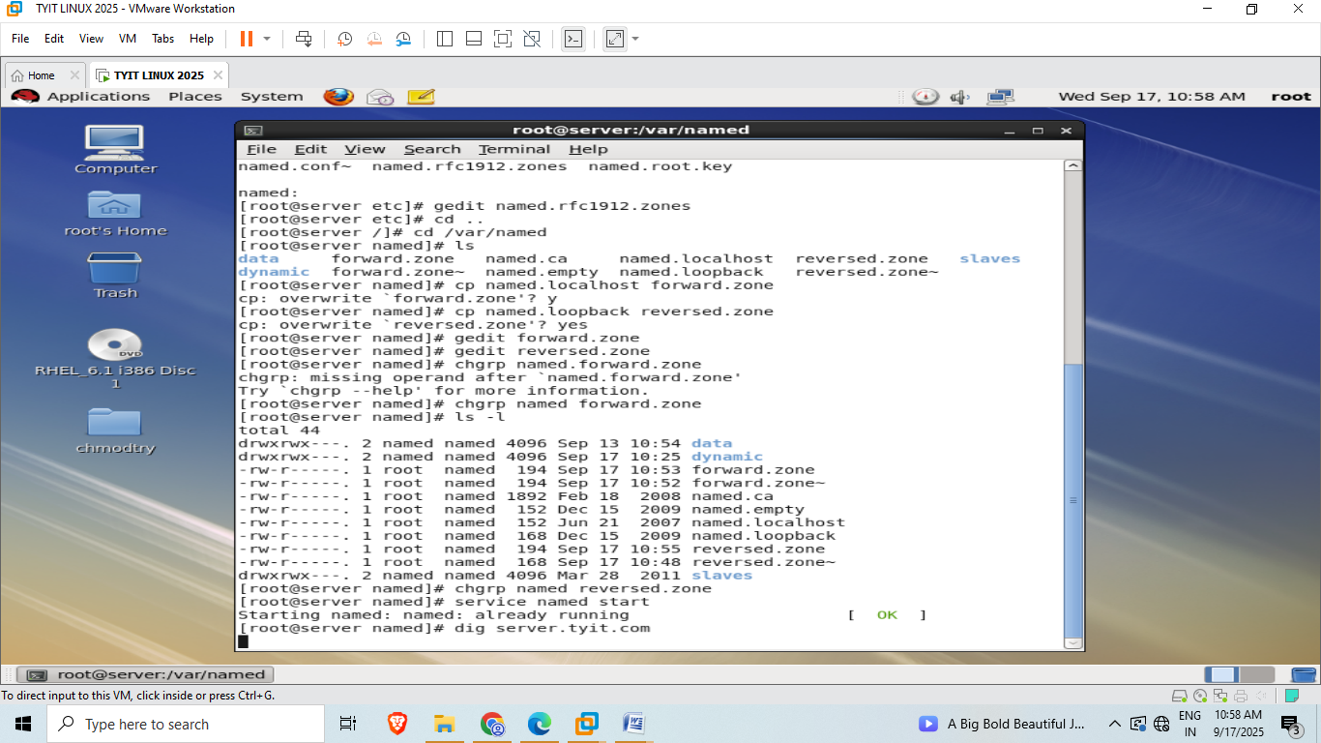  Output:  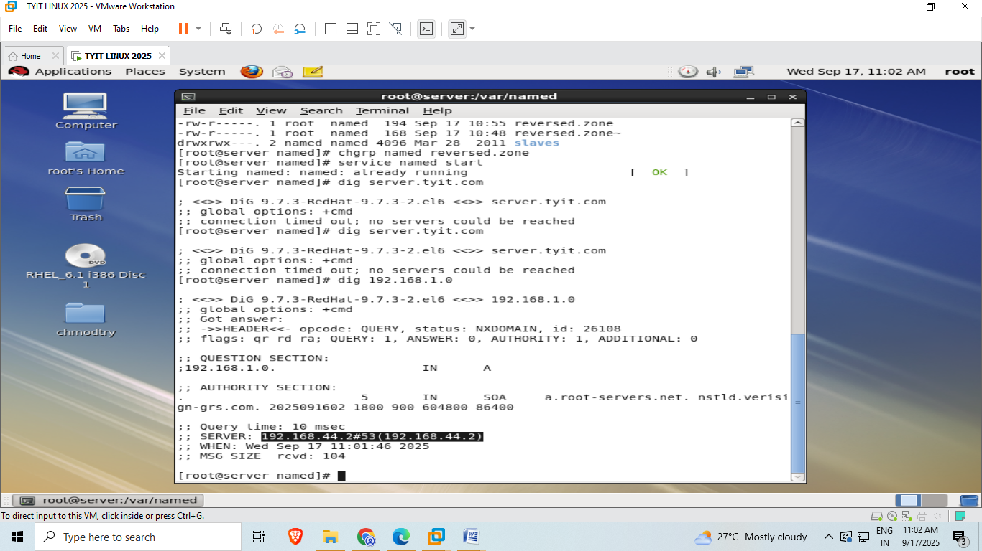––
6B | Configuring DHCP  Ifconfig  For editing – go to network manager.(two pc)  Right click , wired ->system eth0 than edit  Click on manual -> near table ->click add-> put address 192.168.1.3  Net mask – 255.255.255.0  Dns sever – 192.168.1.3  Gateway- 192.168.1.0  Ifconfig  If ip add has changed to 192…. It is correct  If no than type = service network restart.  rpm –qa | grep dhcp  ls  gedit /etc/dhcp/dhcpd.conf  close opend file.  Cp /usr/share/doc/dhcp-4.1.1/dhcpd.conf.sample /etc/dhcp/dhcpd.conf  Overwrite? Yes  gedit /etc/dhcp/dhcpd.conf  go to line subnet 255.255.255.0  (below this is very basic subnet declaration)  Change it to  Service dhcp start  Service dhcp restart  Chkconfig dhcpd on  Chkconfig –list dhcpd  Dhcp 6:off 1:off 2:on  Dhcp server is setup now machine is ready  Close power off  Right click -> manage ->clone ->click->next  Current stare create linked clone 0 first ->next ->clone of red.hat linux  Close  Now clone machine will start  Open og linux machine as root -> systemeth0->edit->manual->apply  Gedit /etc/sysconfig/network-scripts/ifcfg-eth0  Other way  Cd /etc  Cd sysconfig  Cd network-scripts  Gedit ifcfg-eth0  File will open  BOOTPROTO=dhcp (means you are dhcp current )  Now  Service network restatrt  Ok ok wil be displayed  Ifconfig  Minimize-> clone machine -> click right click -> settings -> memory adapter -> custom a virtual machine  Close  ~  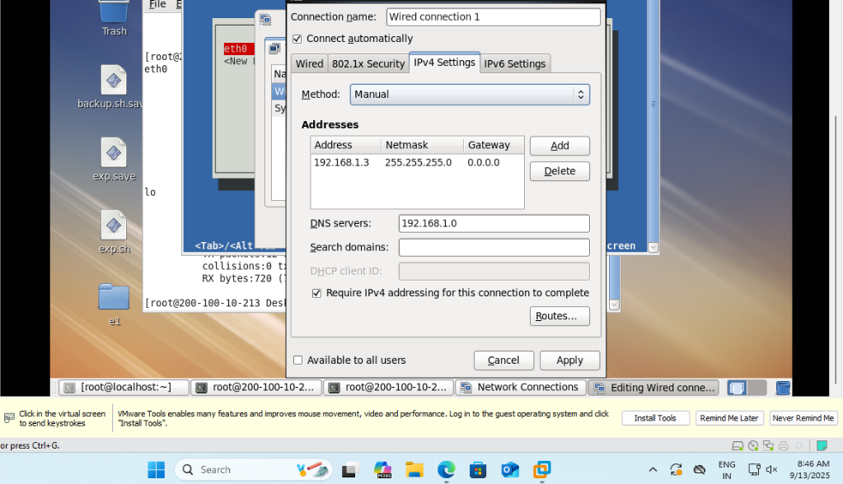  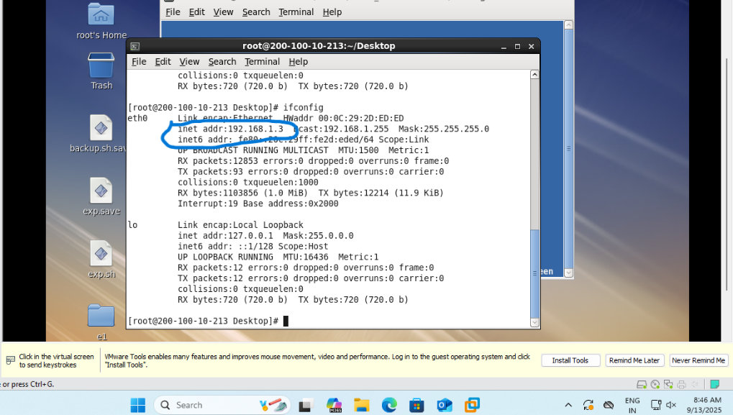  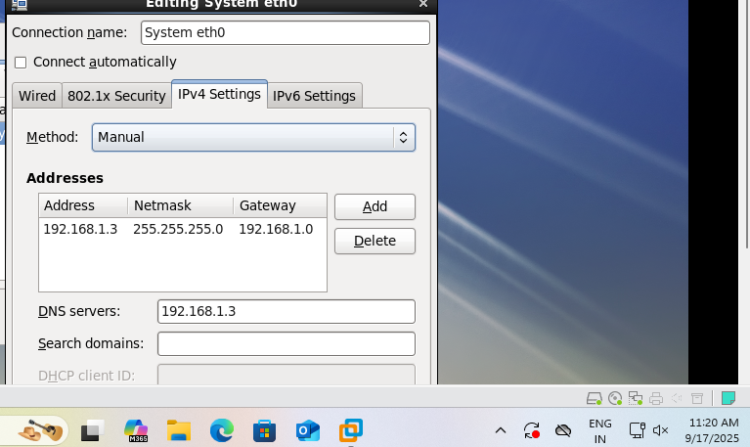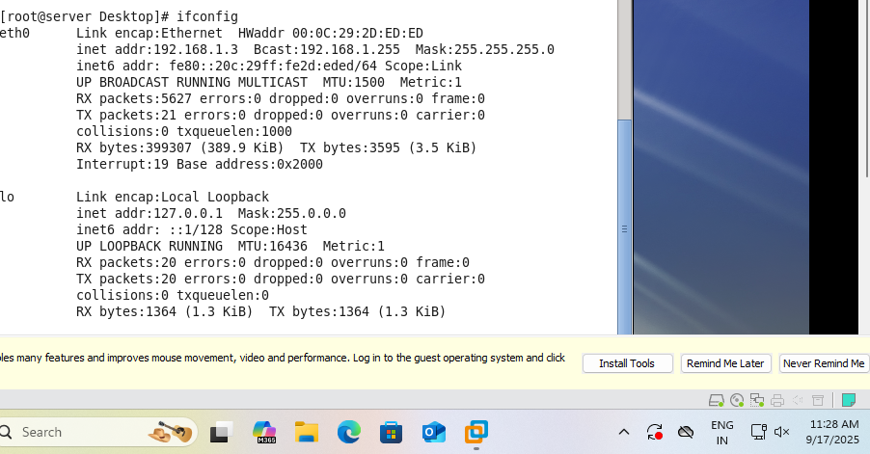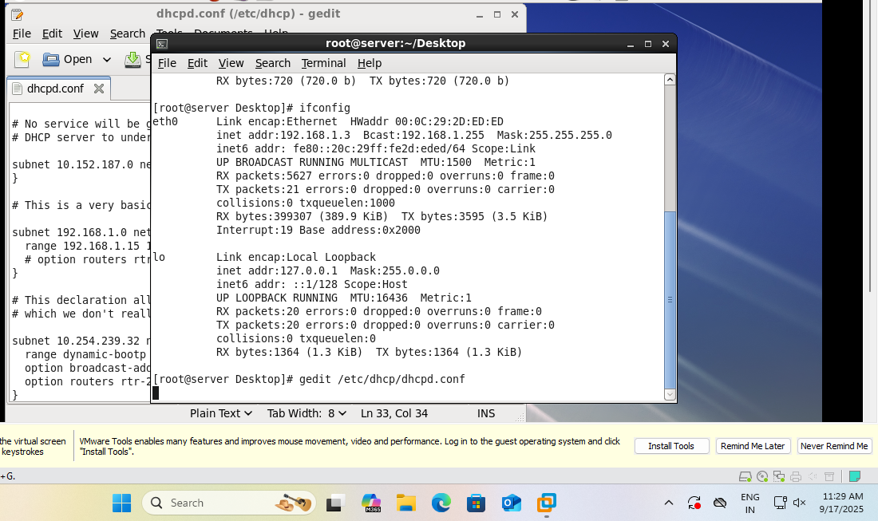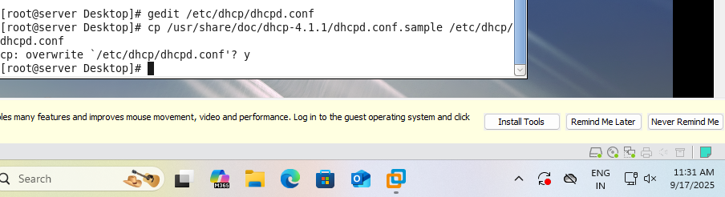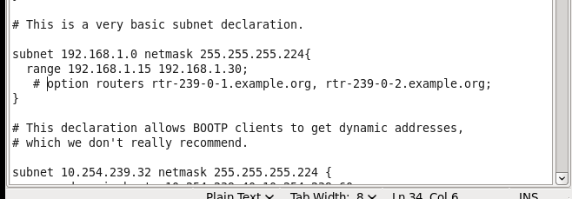  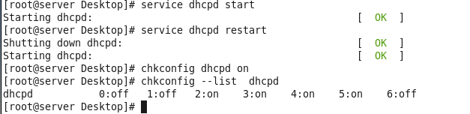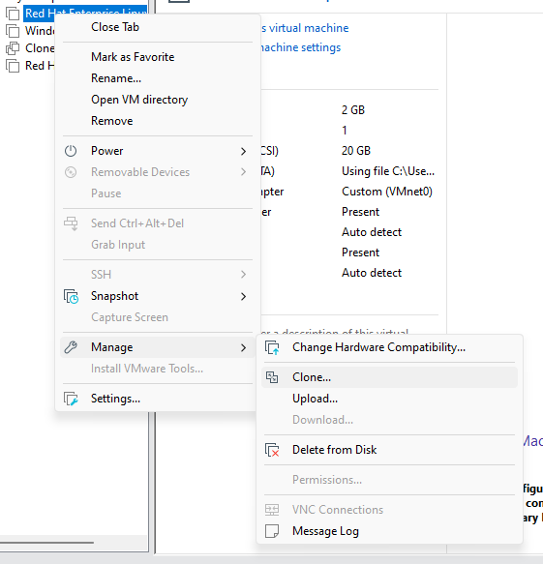    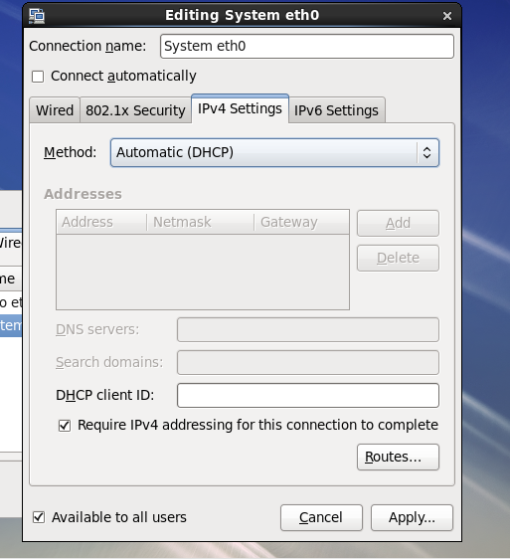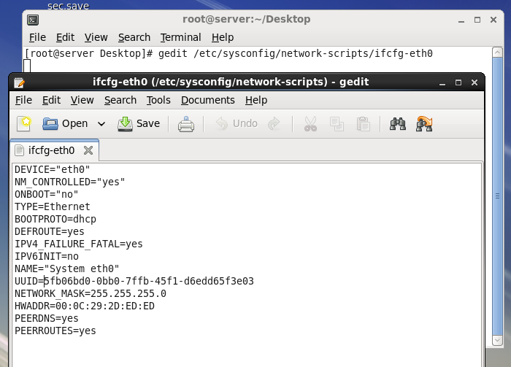  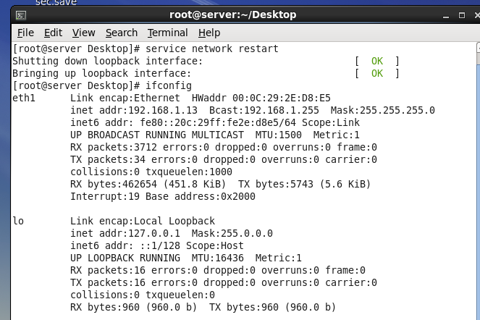  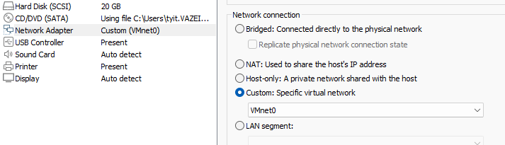  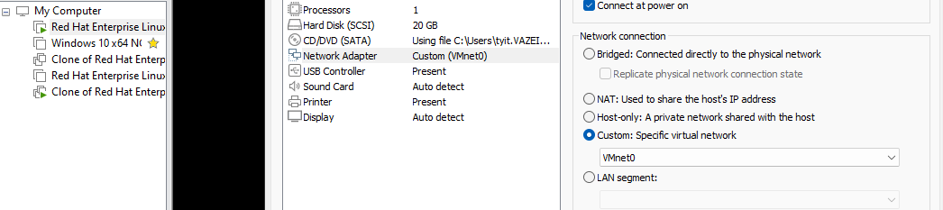  Output on clone machine:  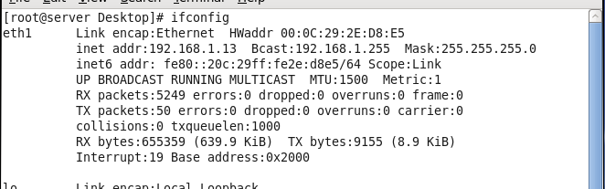
6C | Rpm –qa | grep sendmail  cd..  cd /etc/media/RHEL…/Packages  ls sendmail*  rpm –ivh procmail…ctrl+d  rpm –ivh sendmail…ctrl+d  rpm –ivh sendmail.cf..ctrl+d  (we have to install all three files if it is not available )  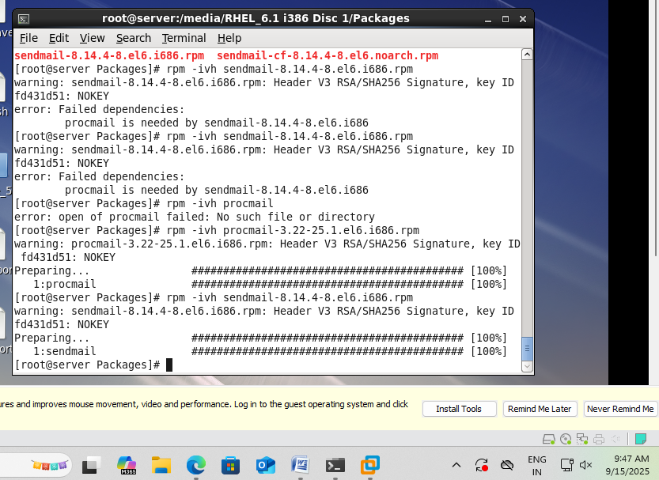  rpm –qa | grep sendmail  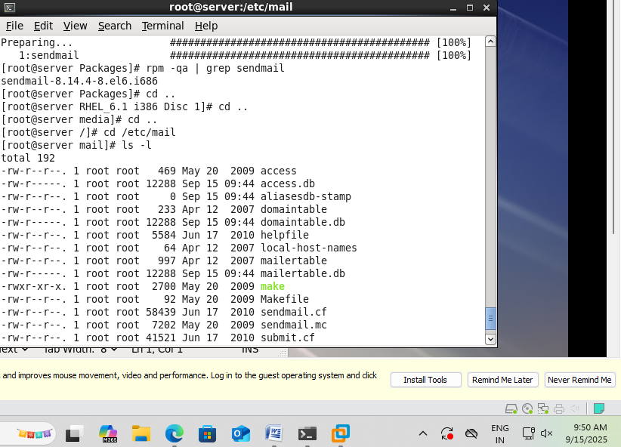  cd ..  cd /etc/mail  gedit sendmail.mc  (comment line 116)  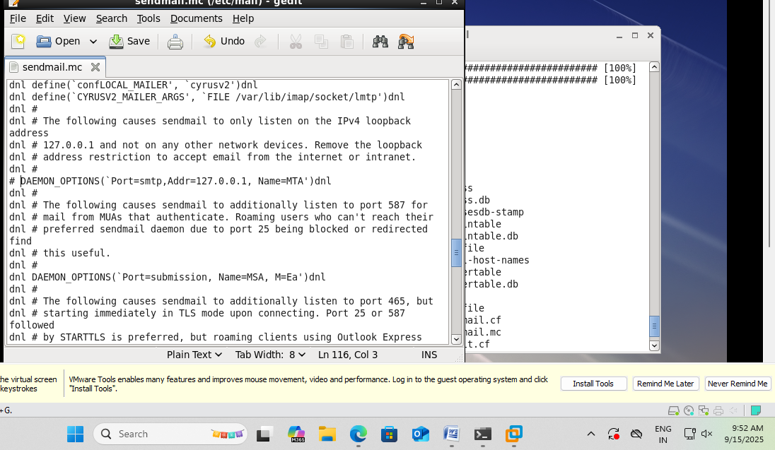  m4 /etc/mail/sendmail.mc > /etc/mail/sendmail.cf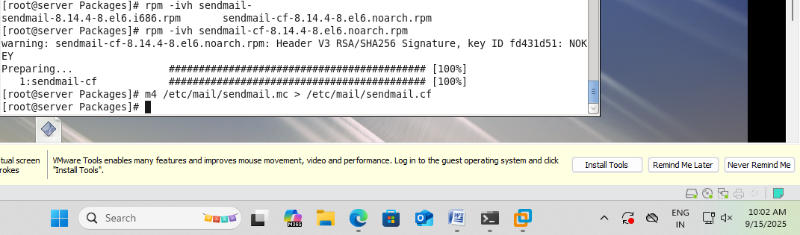  service named start  service sendmail start  dig server.tyit.com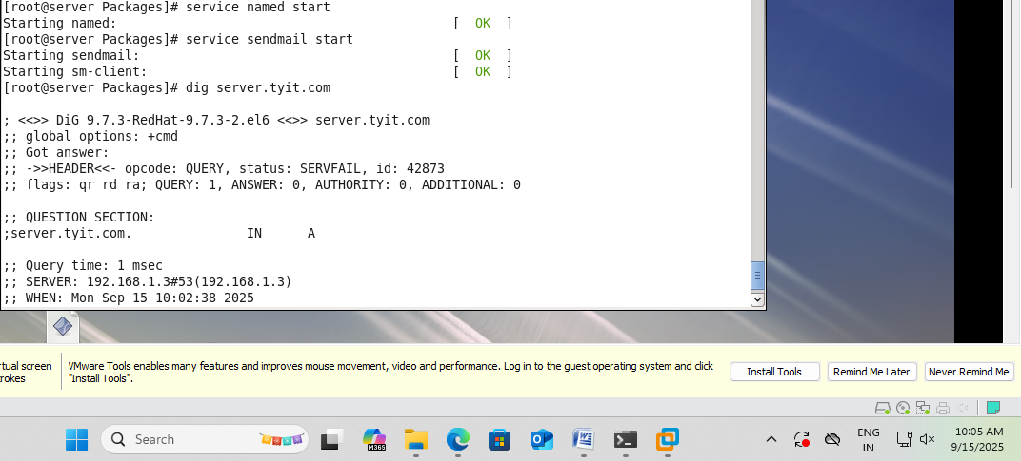  cd /root  Now we will send the mail from root to tyit1  [root@server /]# mail tyit1  Subject : heiww  Body part.  Cntrl + D x2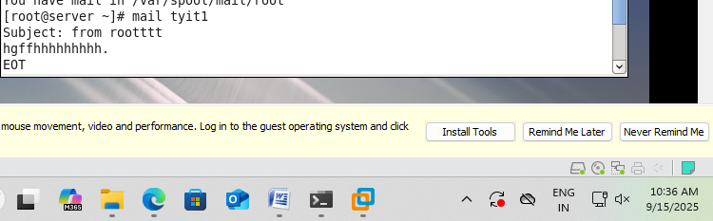  Now , login to tyit1  Open cmd -> Type  mail  the mail sent by the root user is shown here  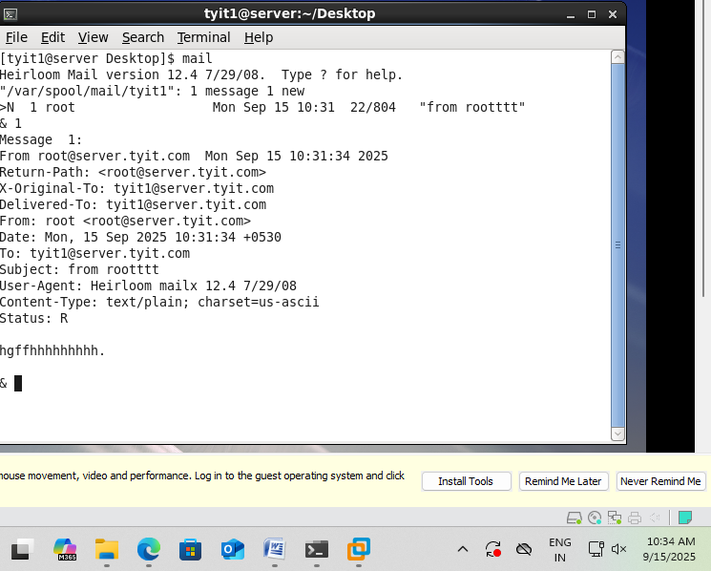

K.E.T’S V.G.VAZE COLLEGE
ROLL NO:A051 NAME: Mrunali.S.Walekar
PRACTICAL 8

PRACTICAL 8 | Shell Scripts
8A | Writing shell scripts  - Write a shell script that will accept directory name if the directory does not exist create a directory create 3 empty files in that directory. If the directory exsit list the content of directory  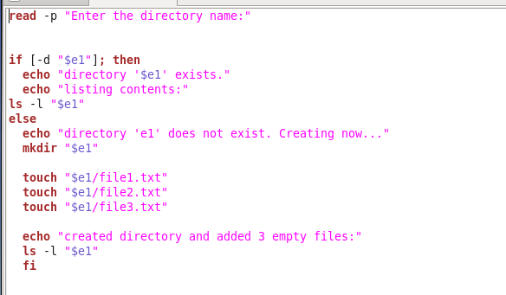  - Write a shell script for process management with the following menu:  - List the name currently logged in users  - Check the group which the current user belongs to  - View the active process  - Find the info of process like (-pid,user,owner,pty,etc)  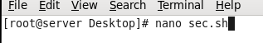  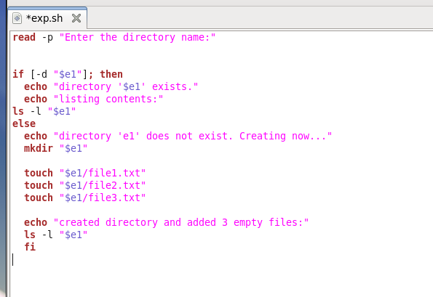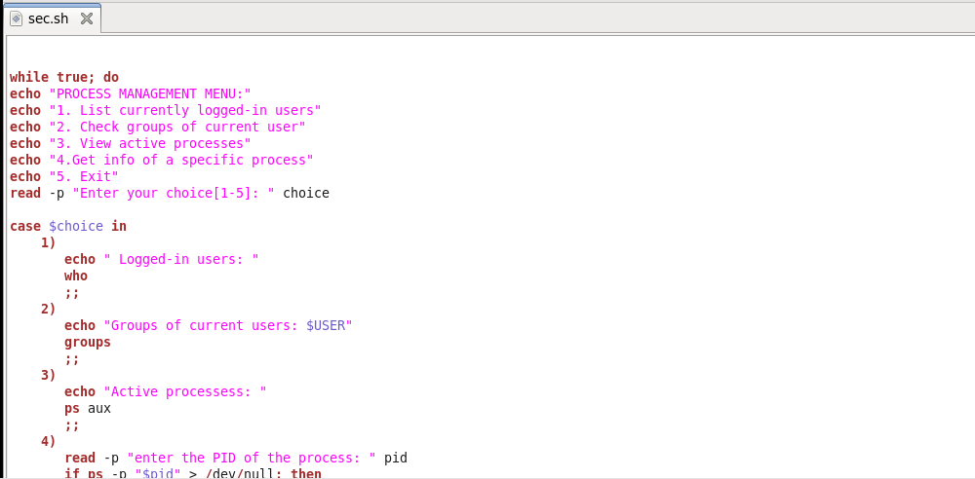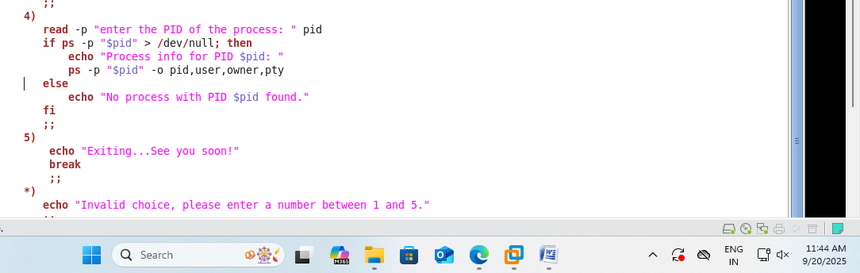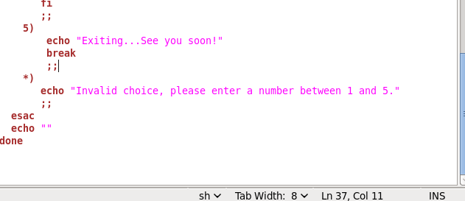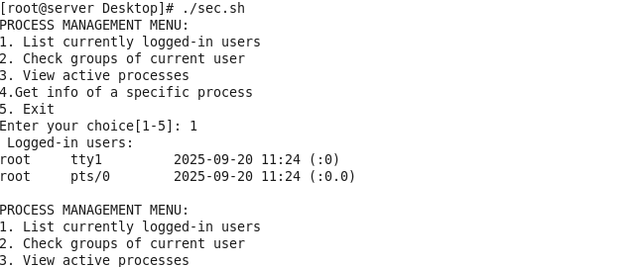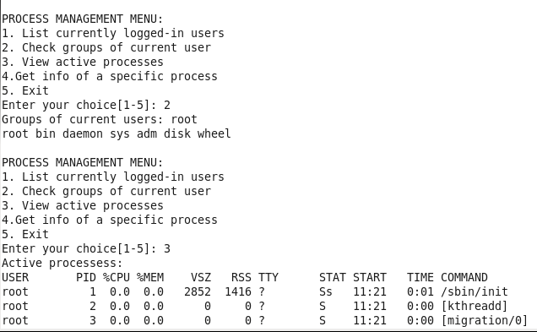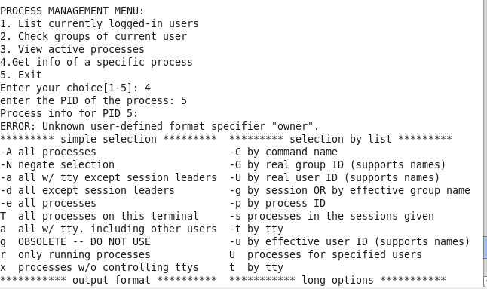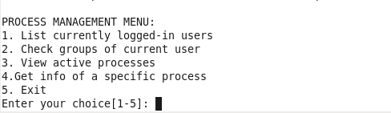  3.Write a shell script for directory management with the following menu:  -create directory (mkdir)  - rename directory  - copy directory  - list the content of directory  - change the directory  - exit the directory
8B

